**ARIGNAR ANNA GOVERNMENT ARTS COLLEGE**

**VILLUPURAM – 605 602.**



**DEPARTMENT OF COMPUTER APPLICATIONS**

|  |
| --- |
|  |

**MACHINE LEARNING WITH PYTHON**

**Project Title : Early Prediction for Chronic Kidney Disease**

**Detection: A Progressive Approach to Health**

**Management**

**Team Id : NM2023TMID16908**

**Team Leader : HEMANATHAN.M**

**Team member:** IYYANAR.M

**Team member:** HEMACHANDRAN**.S**

**Team member:** GOKULRAJ

**Early Prediction for Chronic**

**Kidney Disease Detection: A**

**Progressive Approach to Health Management**

**Abstract**

Every year, an increasing number of patients are diagnosed with late stages of renal disease. Chronic Kidney Disease, also known as Chronic Renal Disease, is characterized by abnormal kidney function or a breakdown of renal function that progresses over months or years. Chronic kidney disease is often found during screening of persons who are known to be at risk for kidney issues, such as those with high blood pressure or diabetes, and those with a blood family who has chronic kidney disease (CKD). As a result, early prognosis is critical in battling the disease and providing effective therapy. Only early identification and continuous monitoring can avoid serious kidney damage or renal failure. Machine Learning (ML) plays a significant part in the healthcare system, and it may efficiently aid and help with decision support in medical institutions. The primary goals of this research are to design and suggest a machine learning method for predicting CKD. Random Forest (LR), Artificial Neural Network (ANN), and Decision Tree are three master teaching methodologies investigated (DT). The components are built using chronic kidney disease datasets, and the outcomes of these models are compared to select the optimal model for prediction.

**Introduction**

Chronic Kidney Disease (CKD) is a major medical problem and can be cured if treated in the early

stages. Usually, people are not aware that medical tests we take for different purposes could contain

valuable information concerning kidney diseases. Consequently, attributes of various medical tests

are investigated to distinguish which attributes may contain helpful information about the disease. The

information says that it helps us to measure the severity of the problem, the predicted survival of the

patient after the illness, the pattern of the disease and work for curing the disease.

In today world as we know most of the people are facing so many disease and as this can be cured

If, we treat people in early stages this project can use a pre trained model to predict the Chronic Kidney

disease which can help in treatments of peoples who are suffer from this disease.

**Purpose**

The rationale for testing asymptomatic people for CKD is that earlier detection might allow for the implementation of therapeutic interventions and avoidance of inappropriate exposure to nephrotoxic agents, both of which may slow the progression of CKD to end-stage kidney disease.

**Problem Definition & Design**

**Thinking**

**Empathy Map**

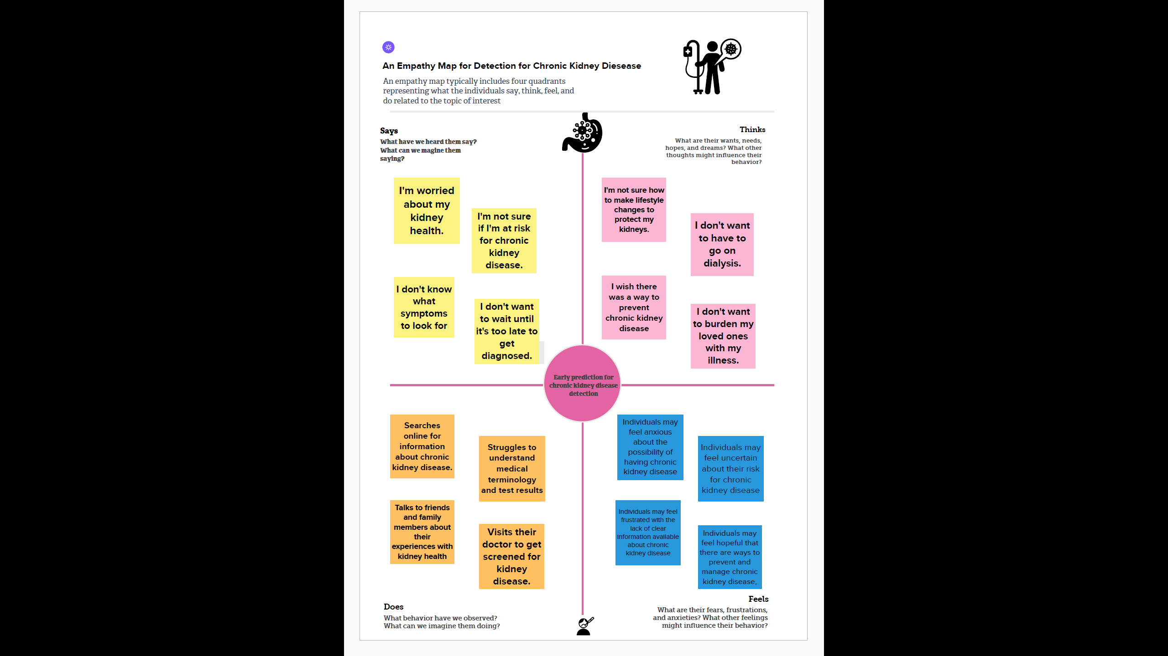

**Ideation & Brainstorming Map**

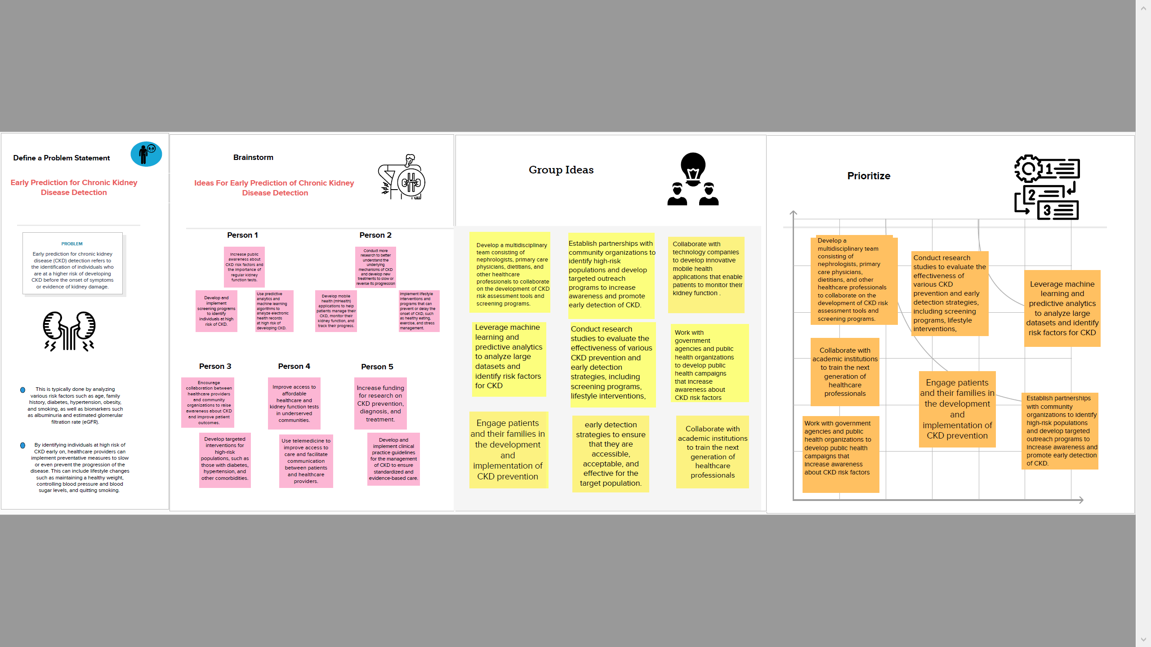

**Result**

The application uses ANN and Naive Bayes Algorithms for classification. The application has Admin module which is the main module to maintain the application. After admin’s successful login he can add doctors and receptionists. The receptionist will add the training dataset (old patient) and register’s the new patient. Doctor can analyze whether a patient have CKD or not and also determine the CKD stage if patient having CKD. Also, doctors have an option to upload treatment details for particular patient. The patient can view his treatment details by logging in to the application.

**Result Image**

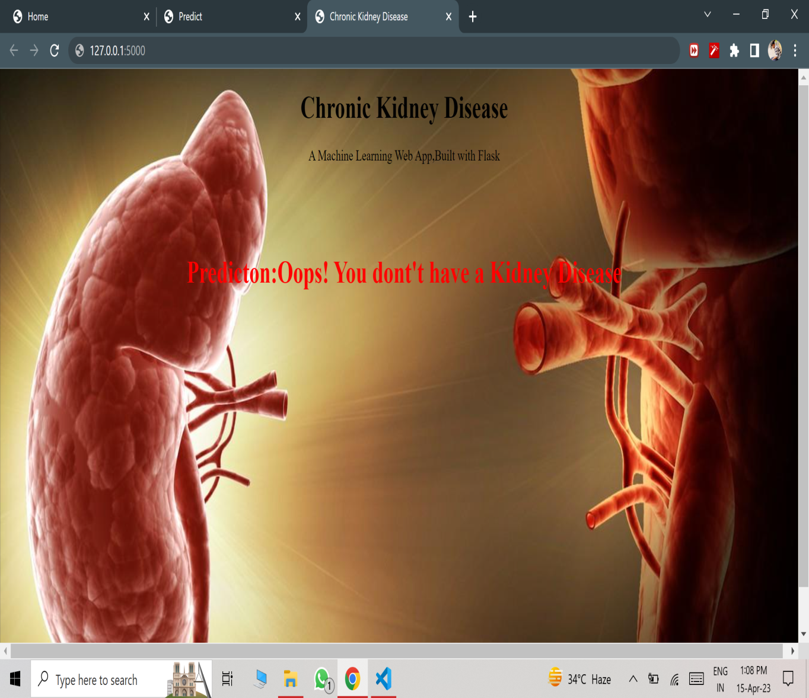

**Advantages & Disadvantages**

**Advantages**

**\***The early detection of CKD allows patients to receive timely treatment, slowing the disease's progression. Due to its rapid recognition performance and accuracy, machine learning models can effectively assist physicians in achieving this goal.

**\***Your kidneys act like a filter to remove wastes and extra fluid from your body. Your kidneys filter about 200 quarts of blood each day to make about 1 to 2 quarts of urine. The urine contains wastes and extra fluid. This prevents buildup of wastes and fluid to keep your body healthy.

**Disadvantage**

____________________________________________________

**\***Having CKD increases the chances of having heart disease and stroke.

**\***Managing high blood pressure, blood sugar, and cholesterol levels—all factors that increase the risk for heart disease and stroke—is very important for people with CKD.

**Applications**

Predictive analytics using machine learning helps detect fraudulent activities in the financial sector. Fraudulent transactions are identified by training machine learning algorithms with past datasets. The models find risky patterns in these datasets and learn to predict and deter fraud.

**Conclusion**

**\***This project is a medical sector application which helps the medical practitioners in predicting the CKD disease based on the CKD parameters. It is automation for CKD disease prediction and it identifiesthe disease, its stages in an efficient and economically manner

**\***It is successfully accomplished by applying the ANN for classification. This classification technique comes under data mining technology. This algorithm takes CKD parameters as input and predicts the disease based on old CKD patient’s data.

**Future scope**

The work will be considered as basement for the healthcare system for CKD patients. Also extension to this work is that implementation of deep learning since deep learning provides high-quality performance than machine learning algorithm.

**Source Code**

**Milestone 2:**

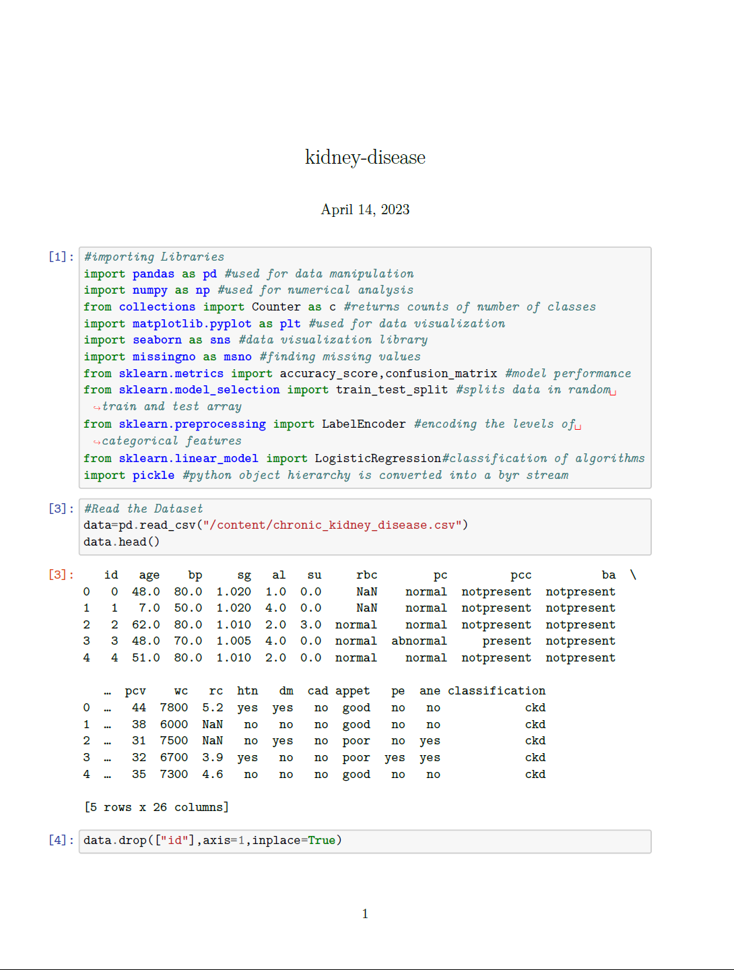

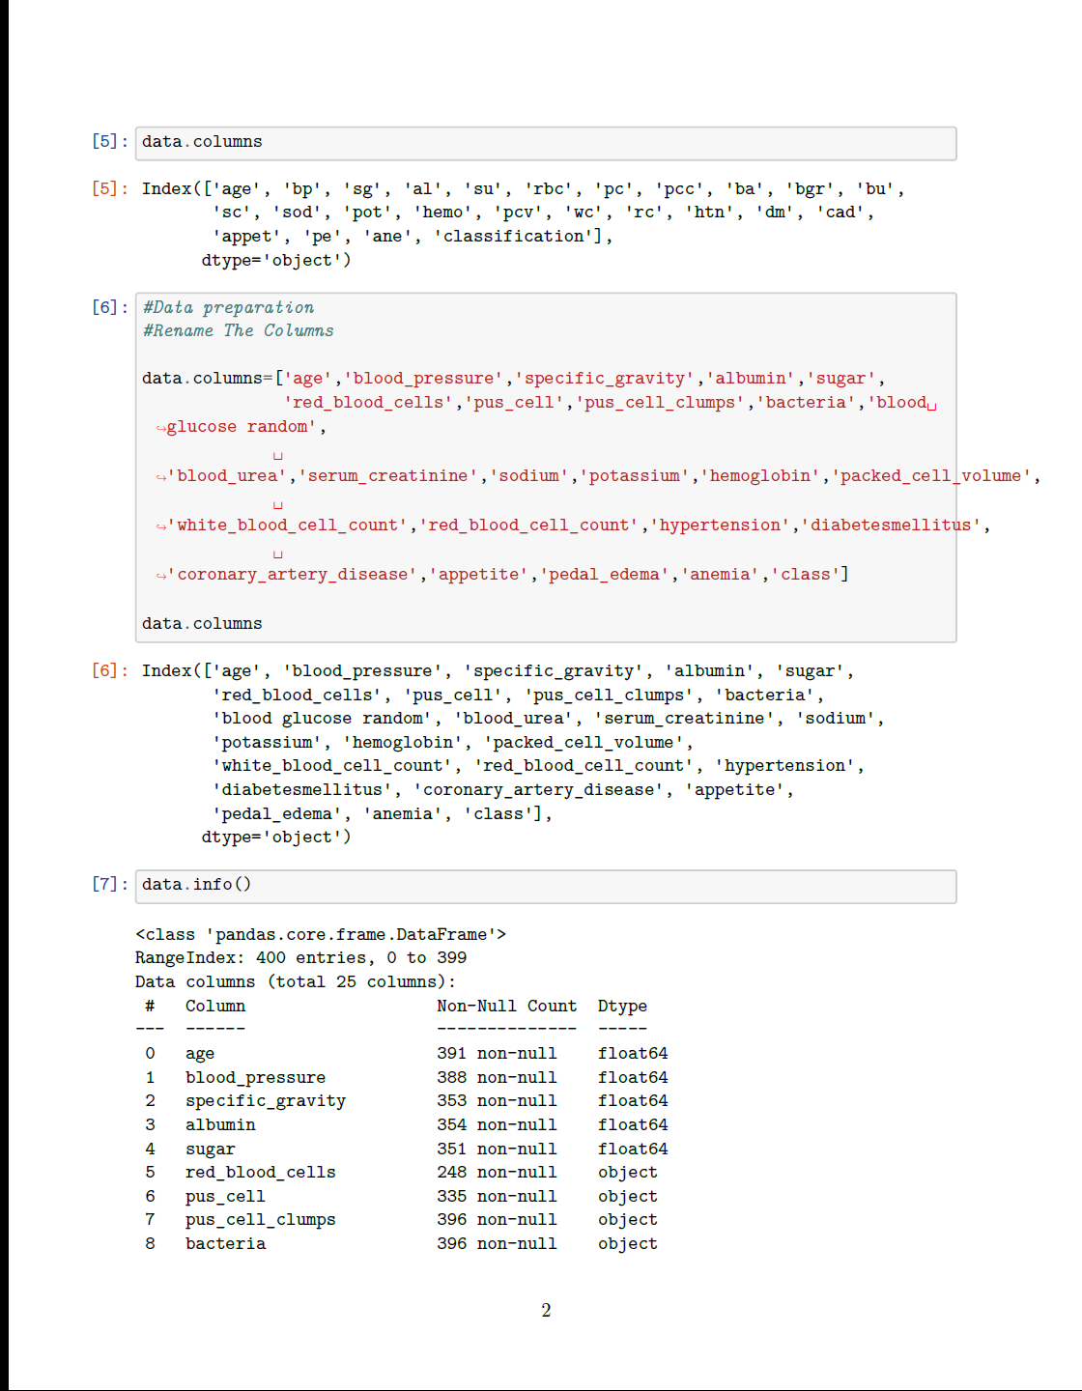

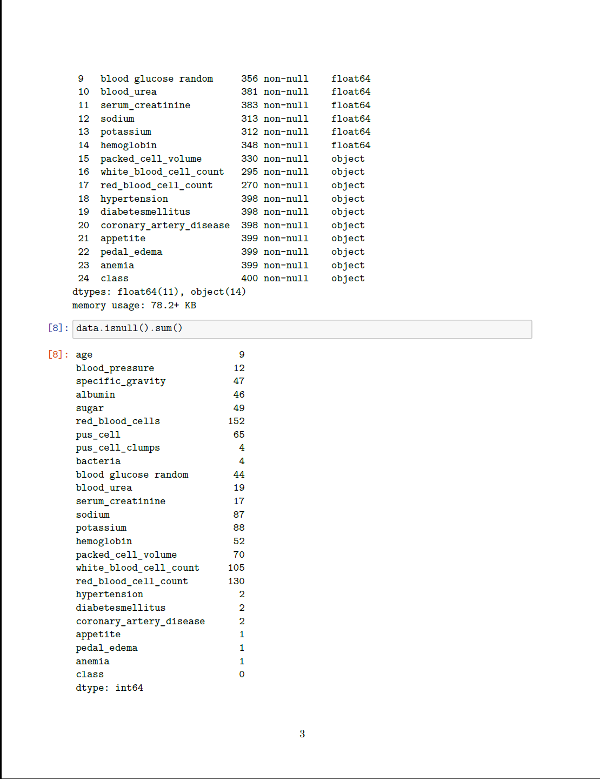

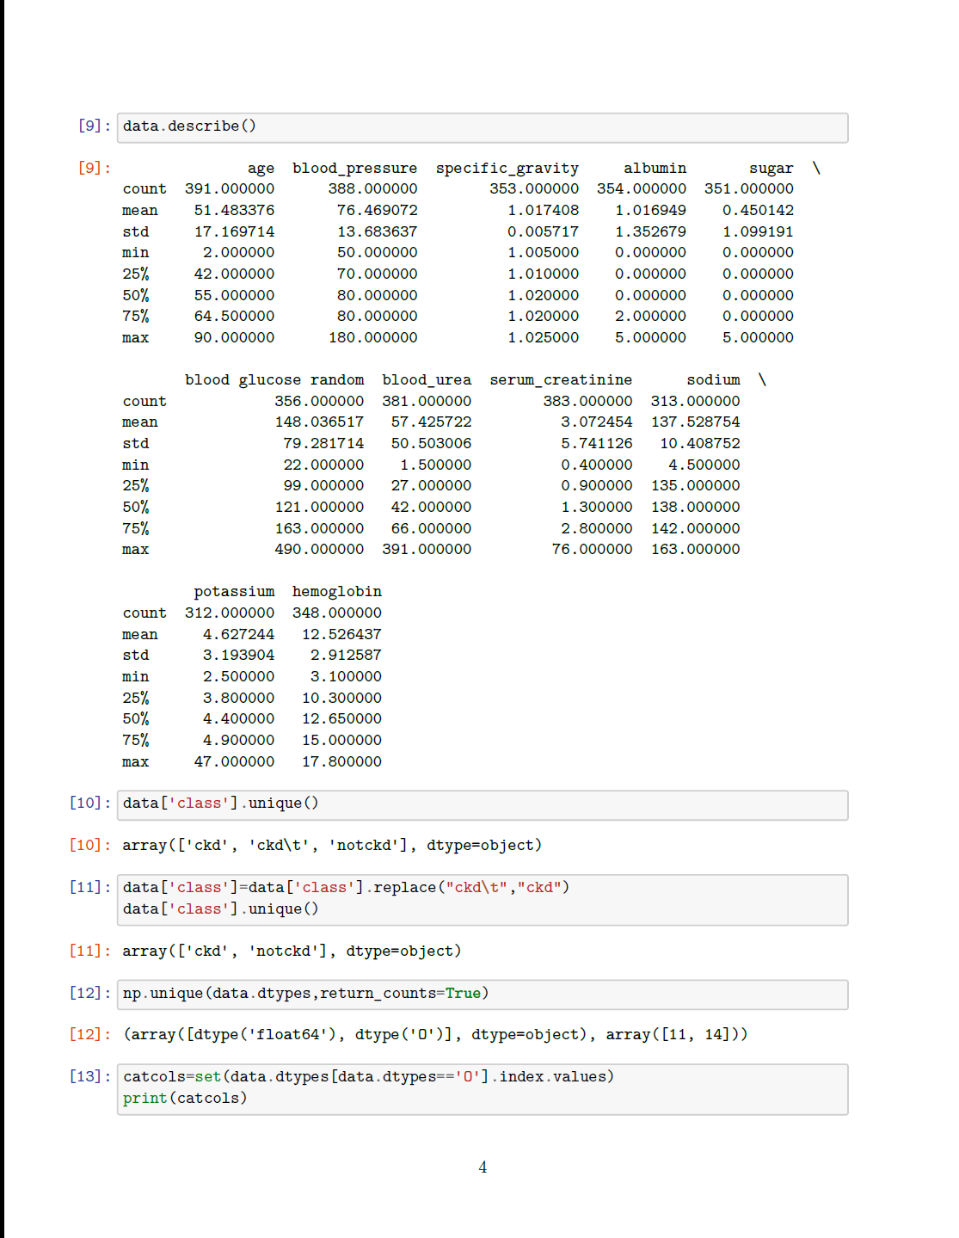

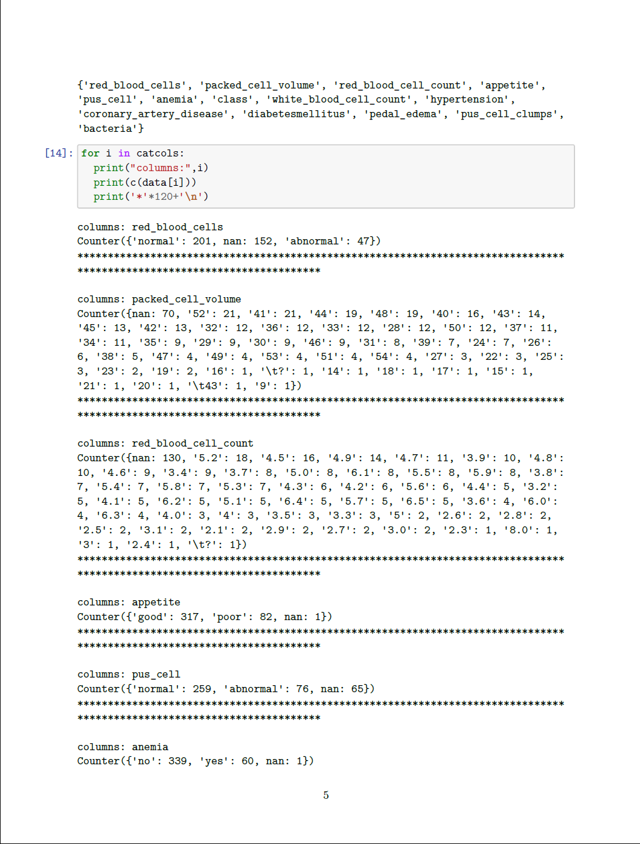

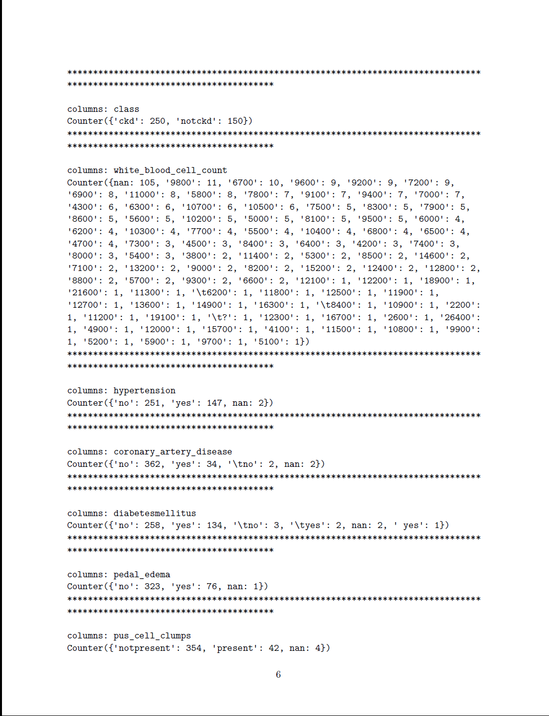

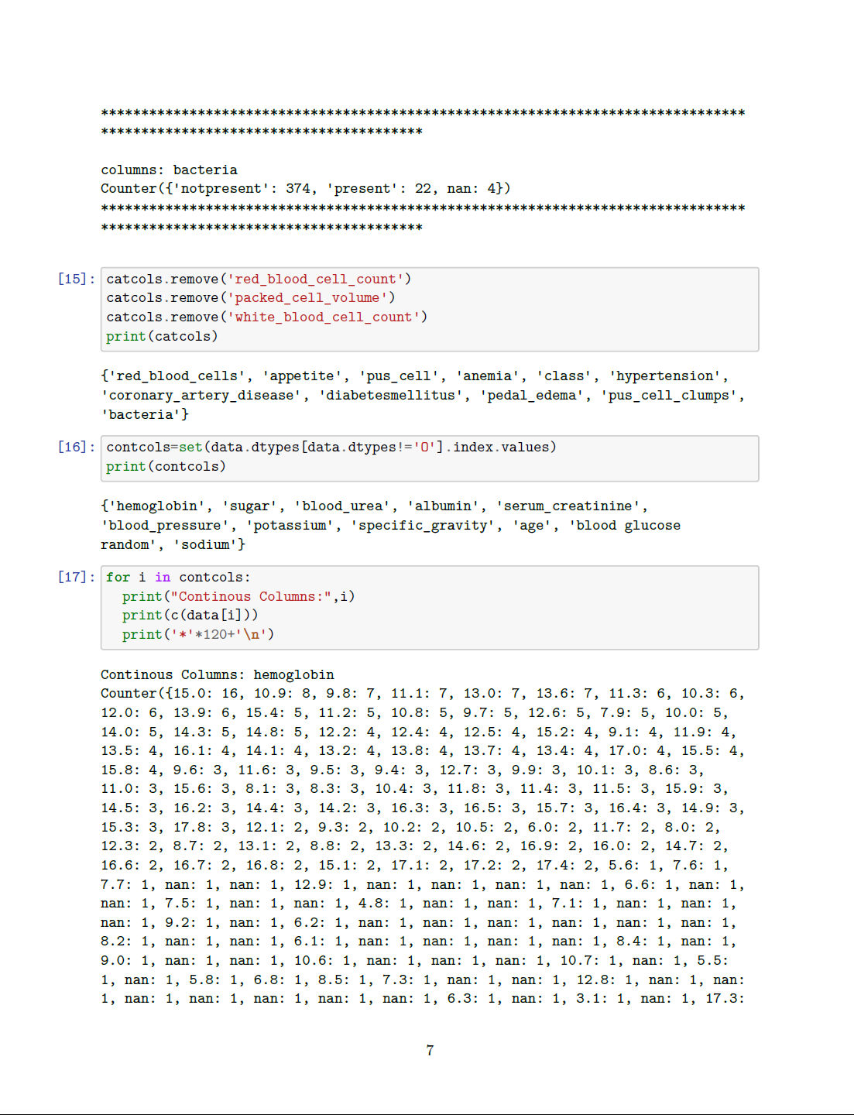

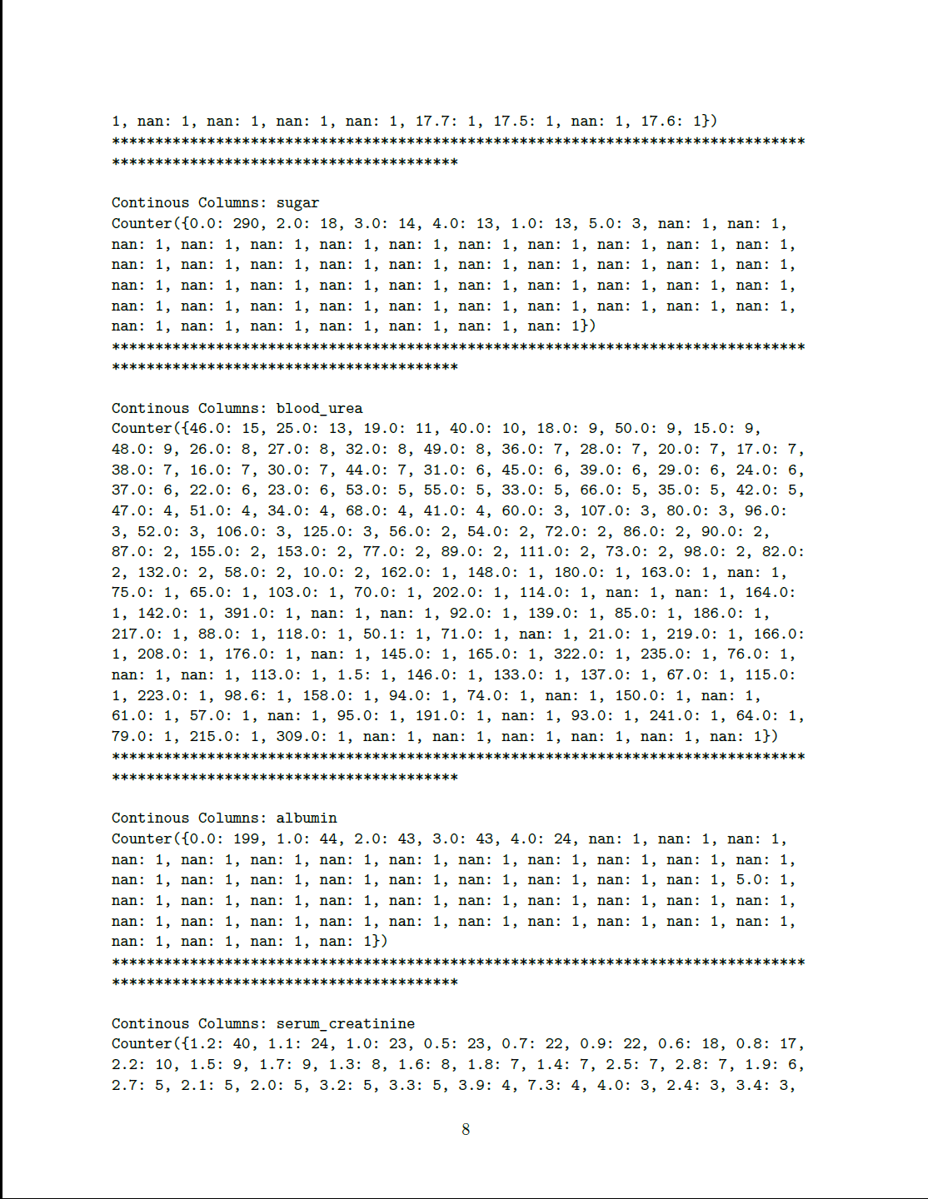

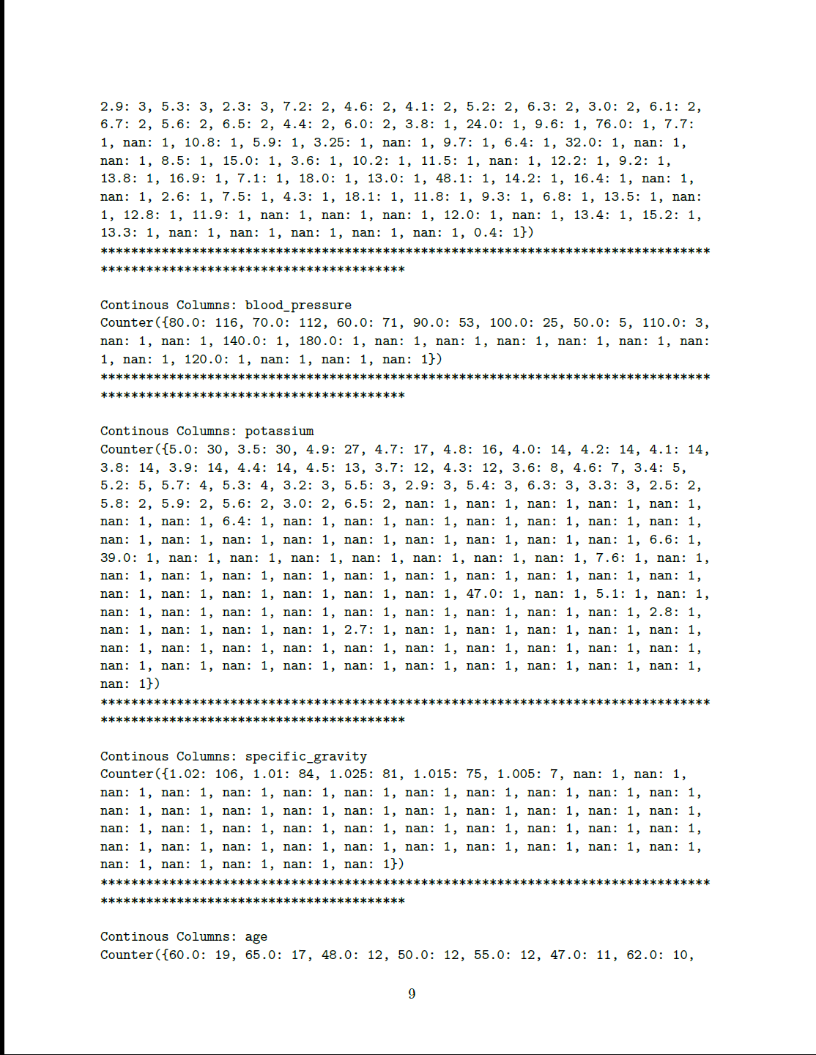

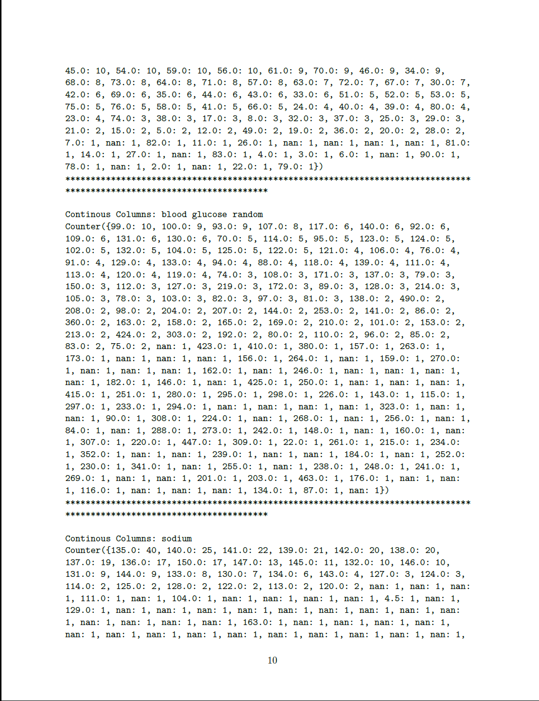

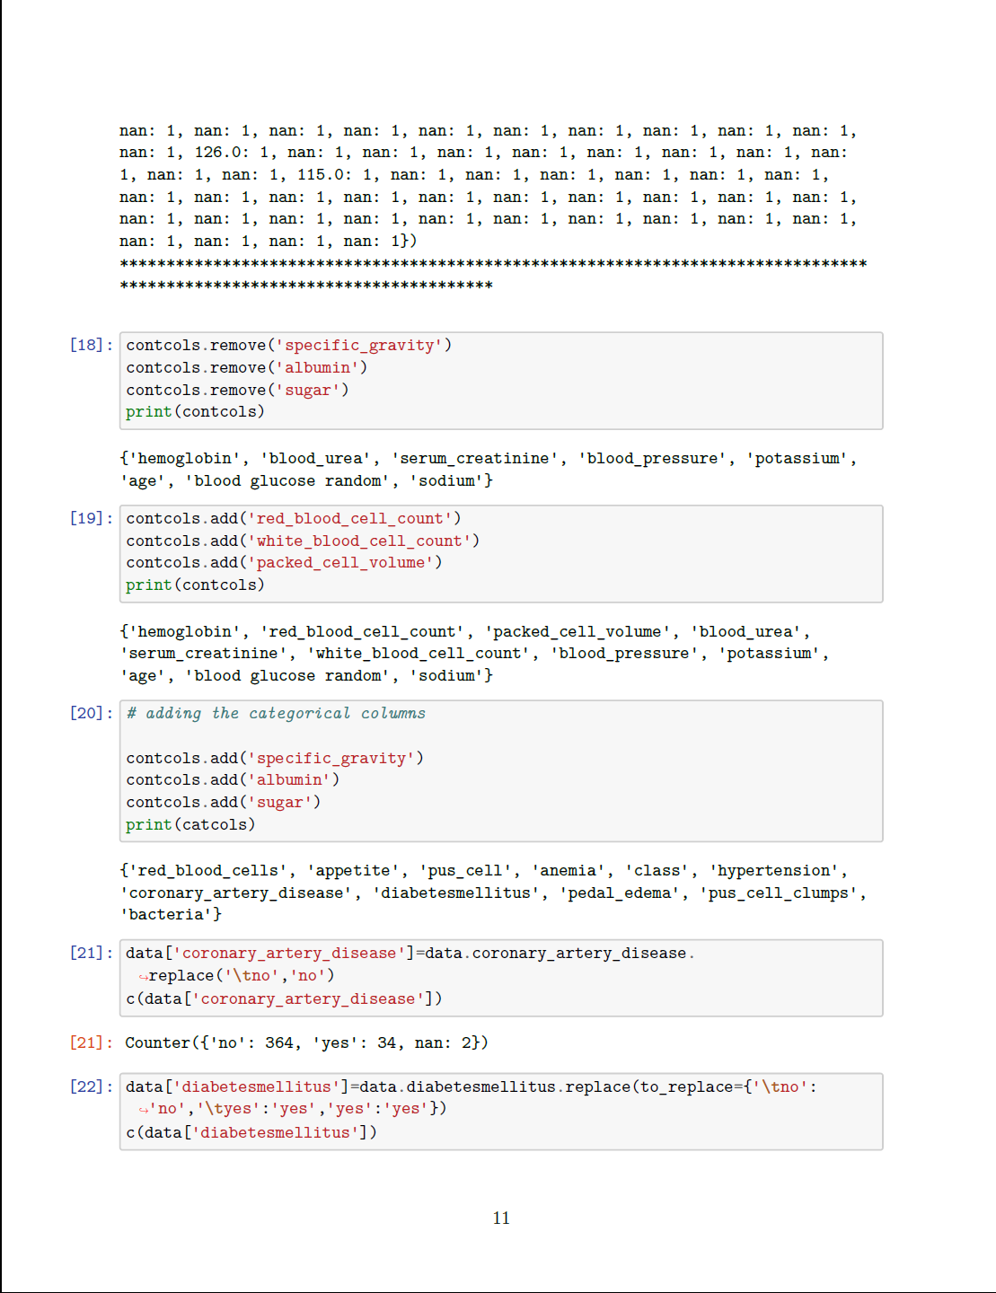

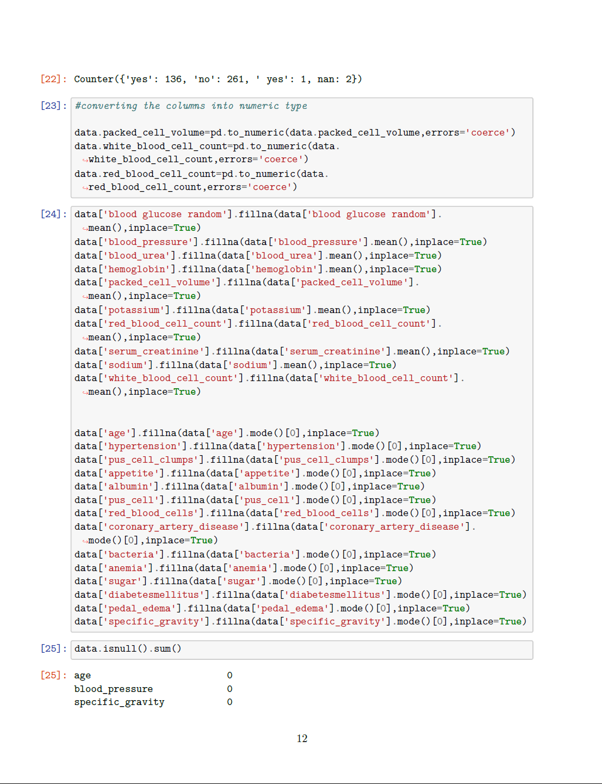

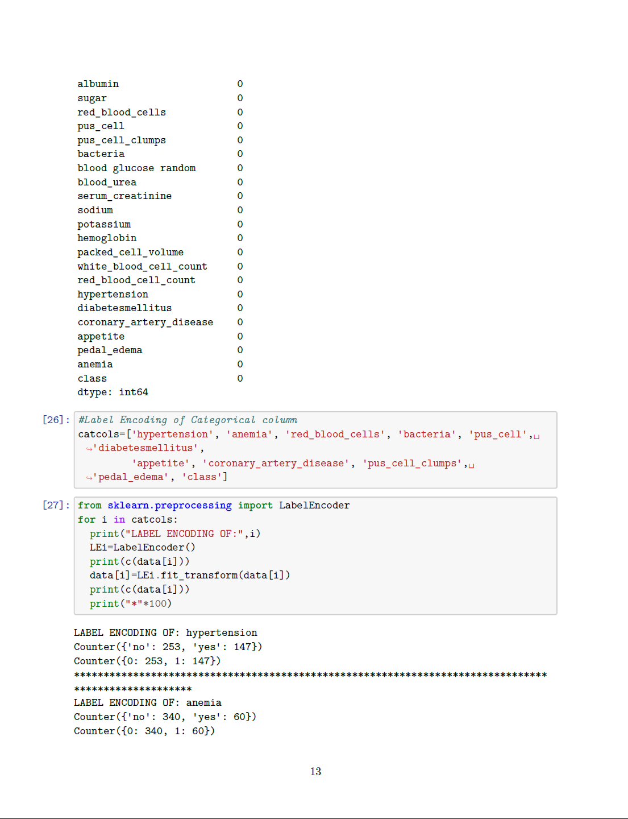

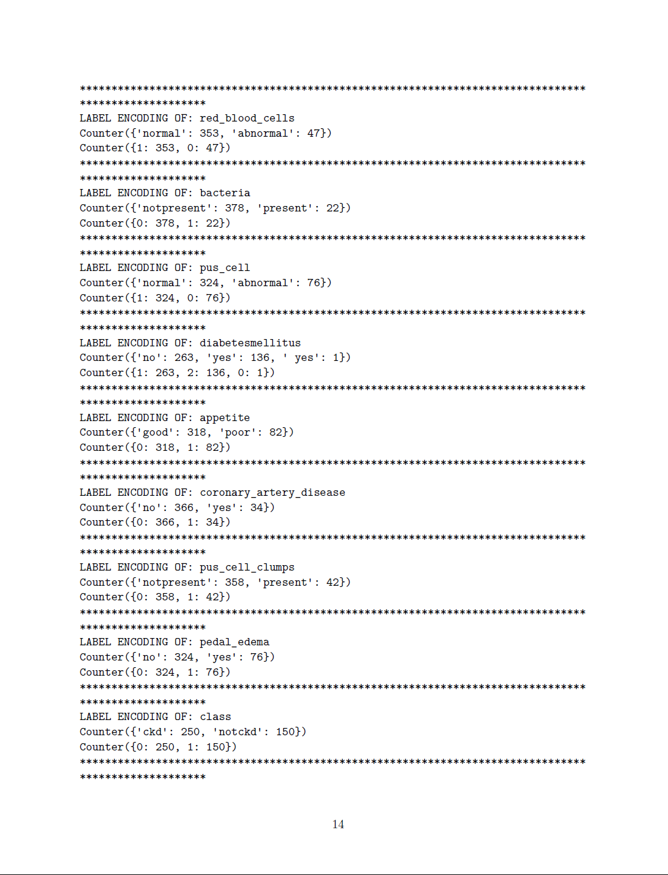

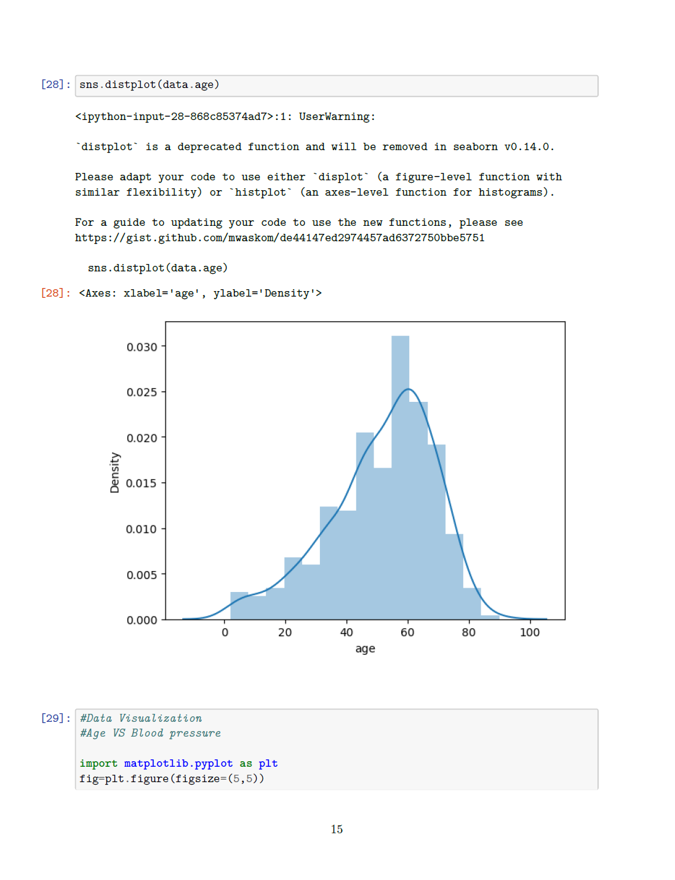

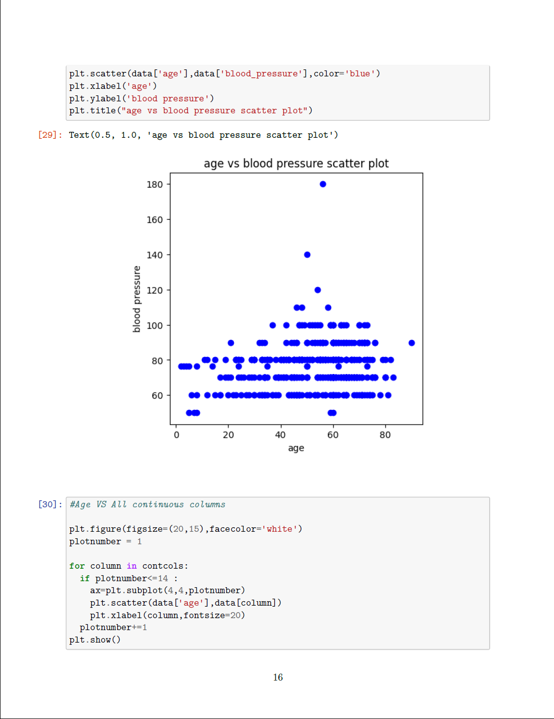

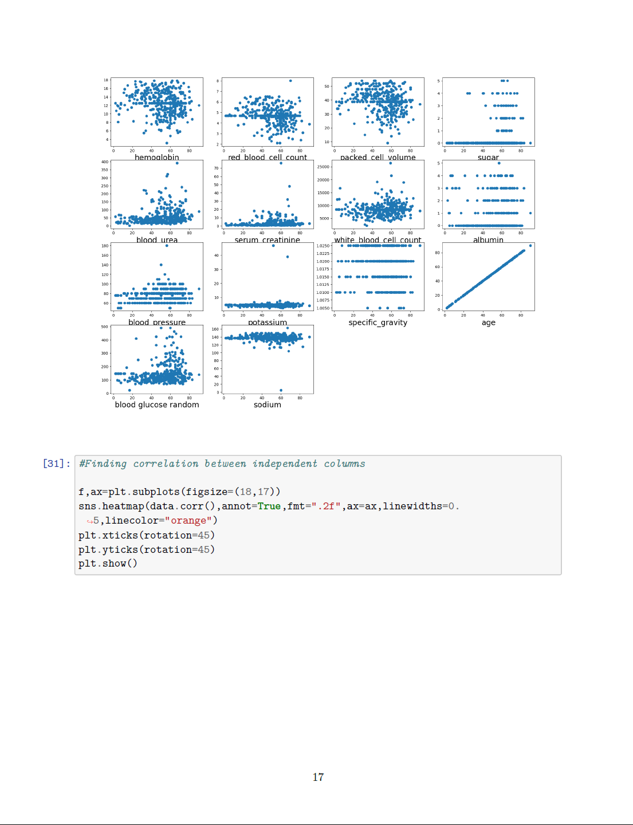

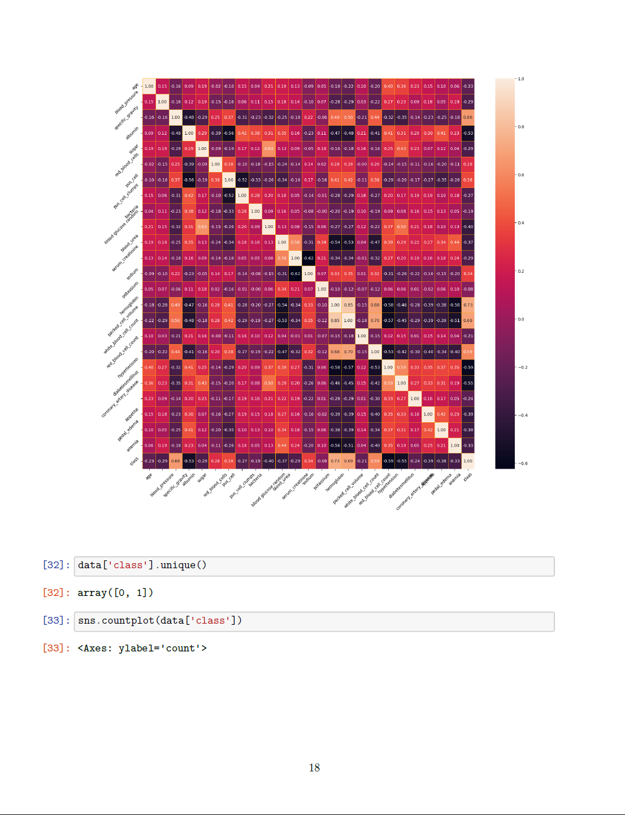

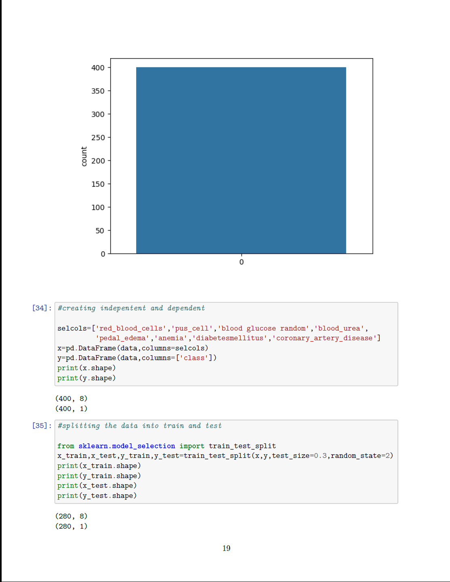

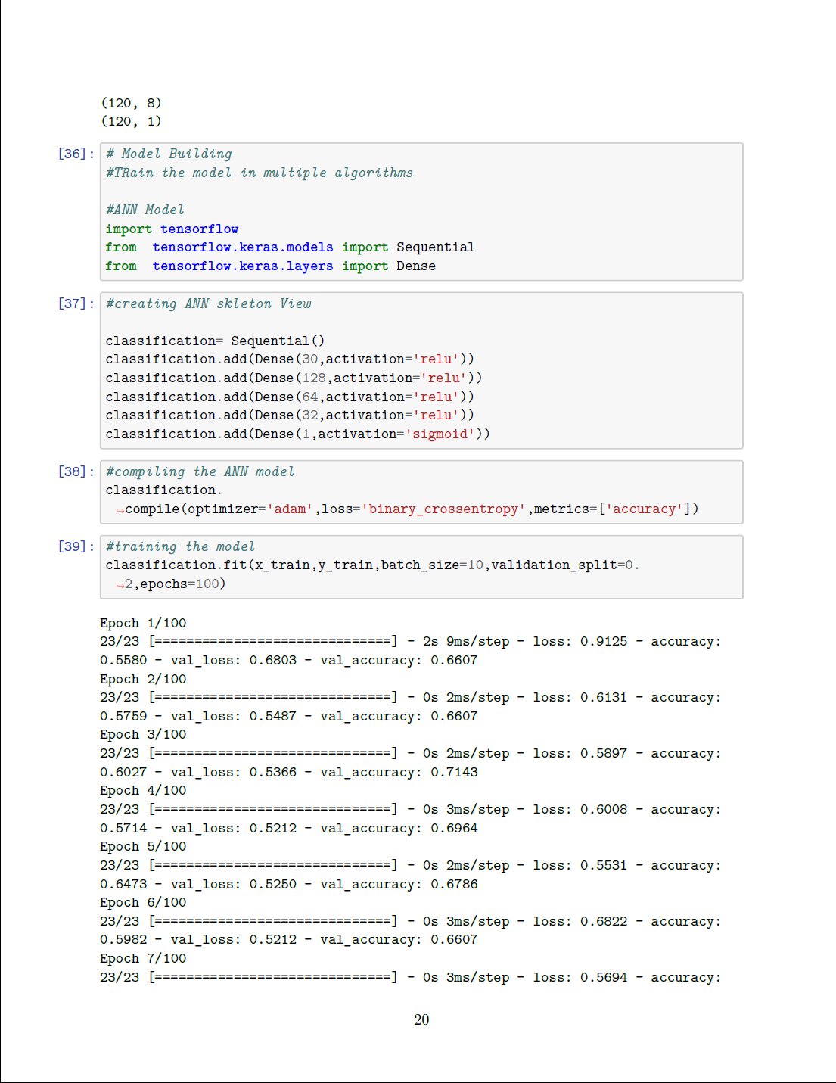

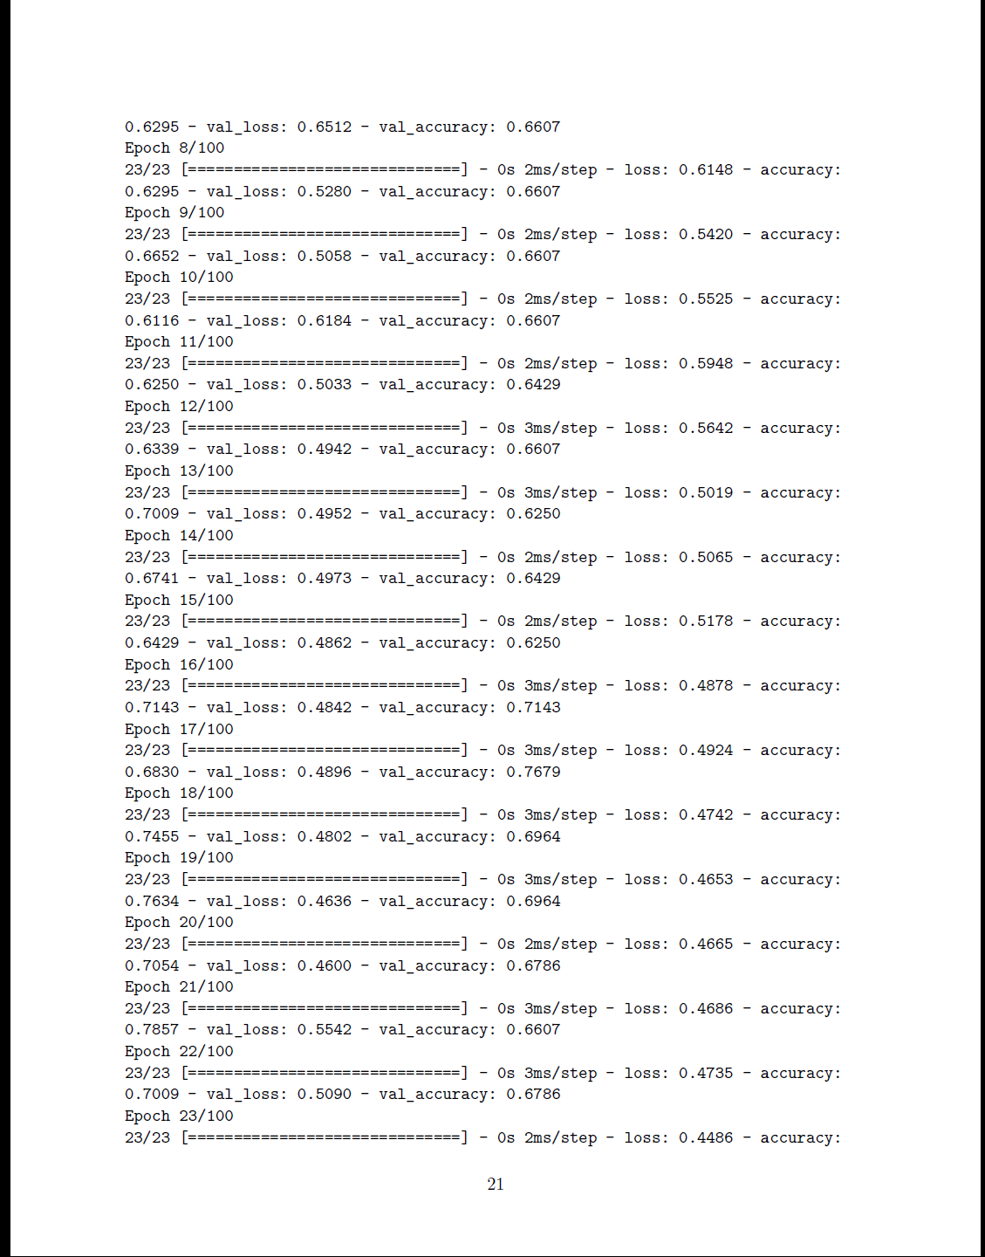

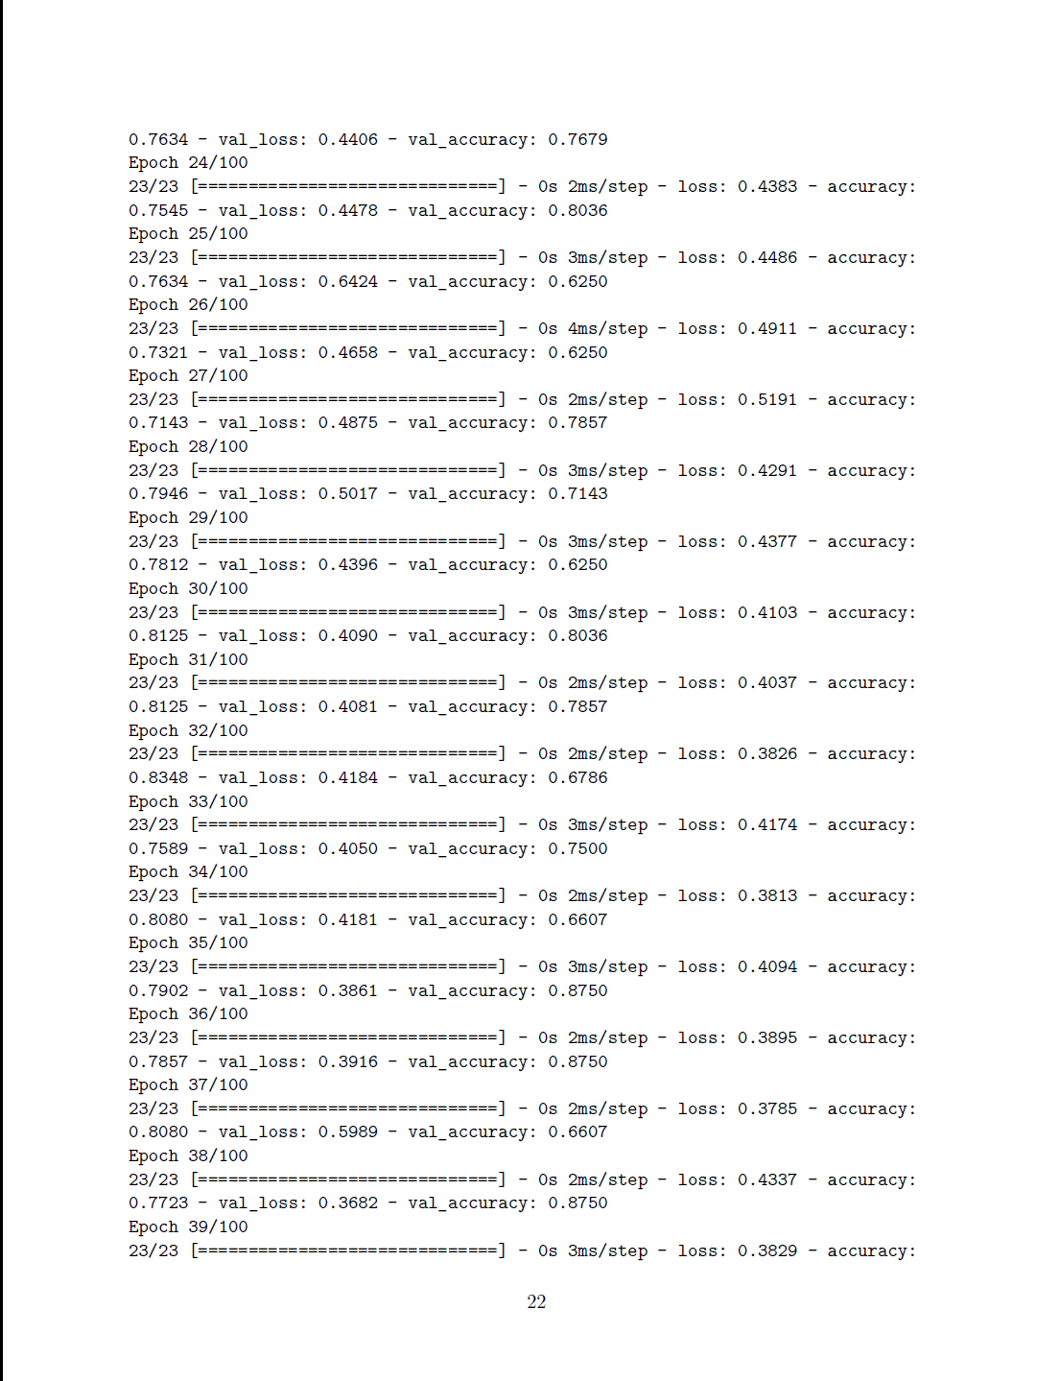

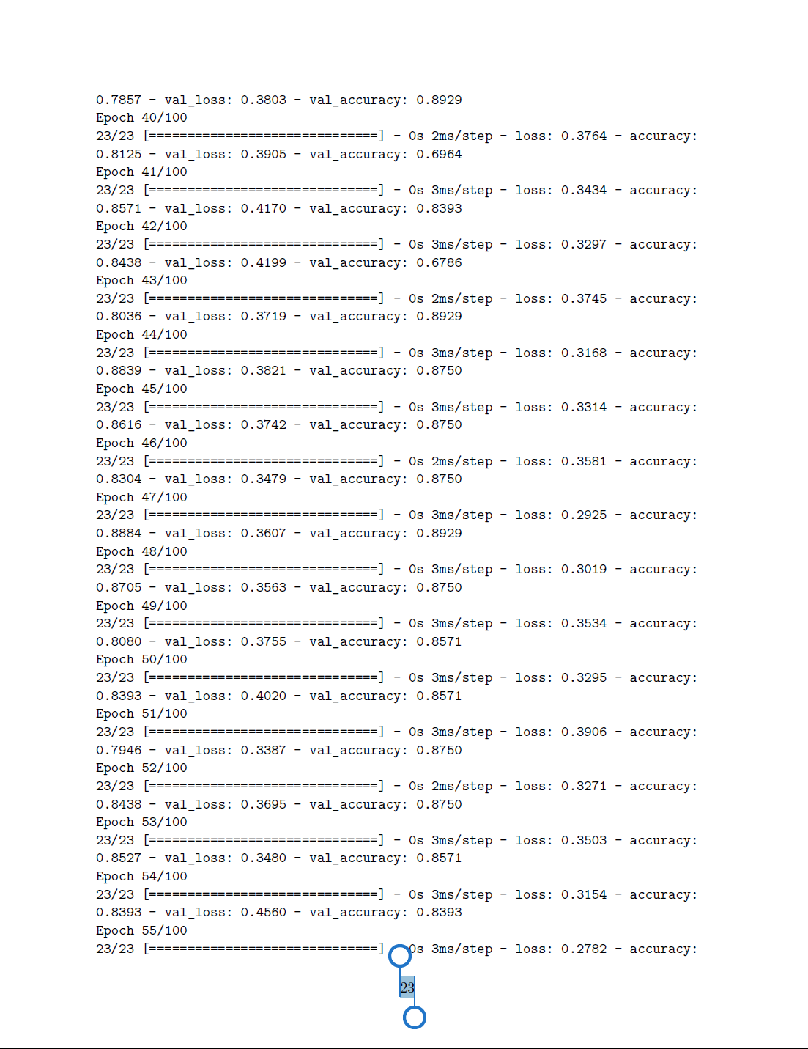

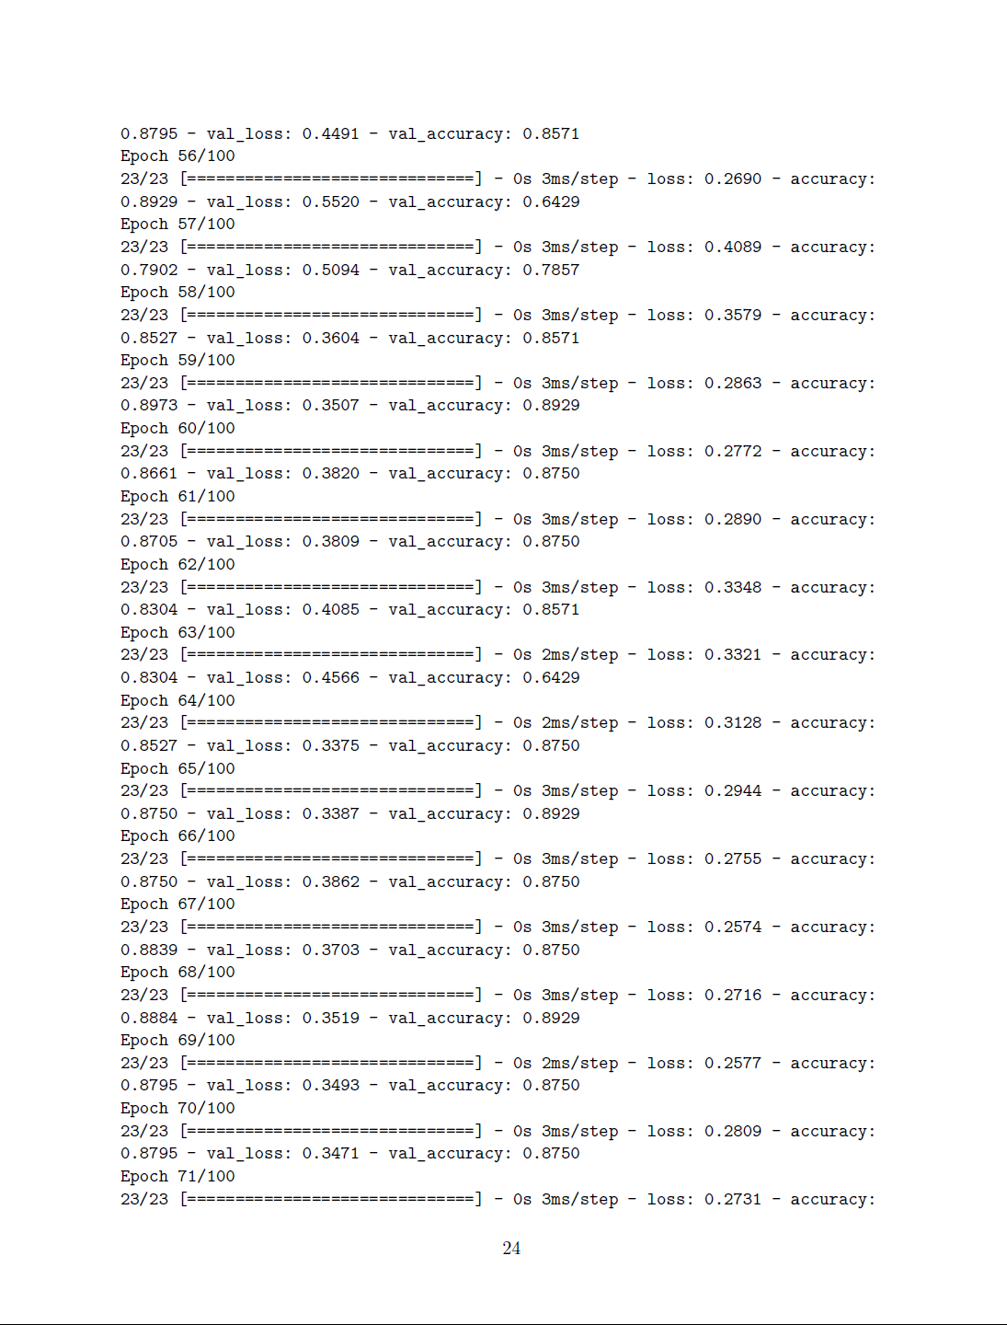

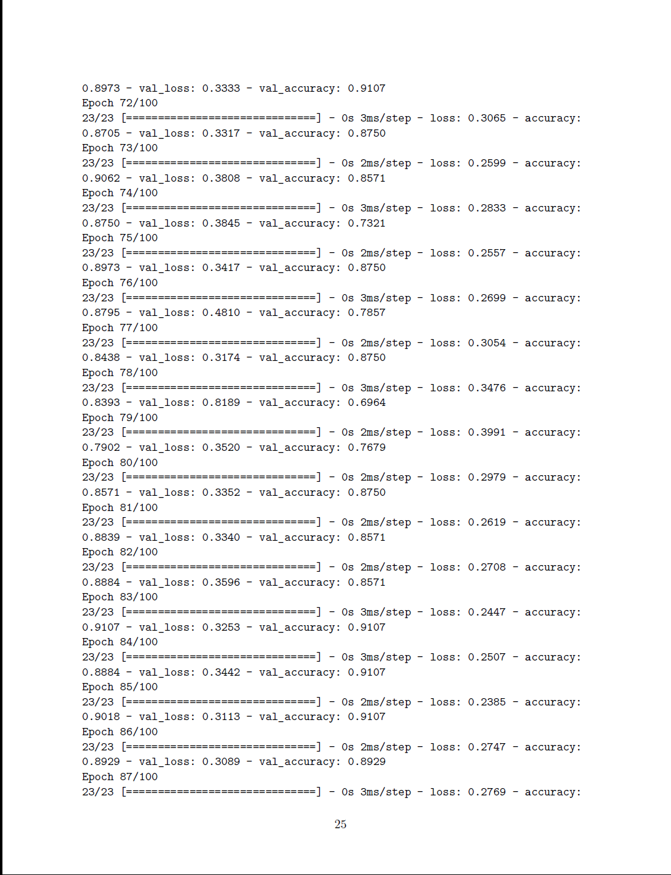

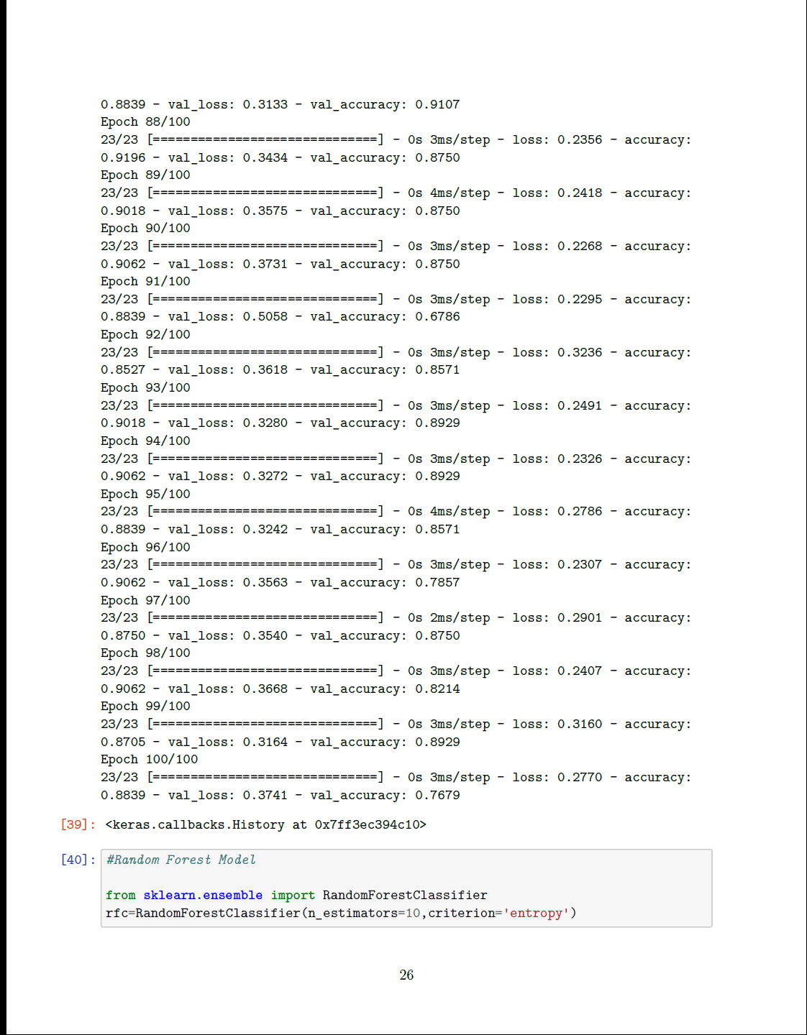

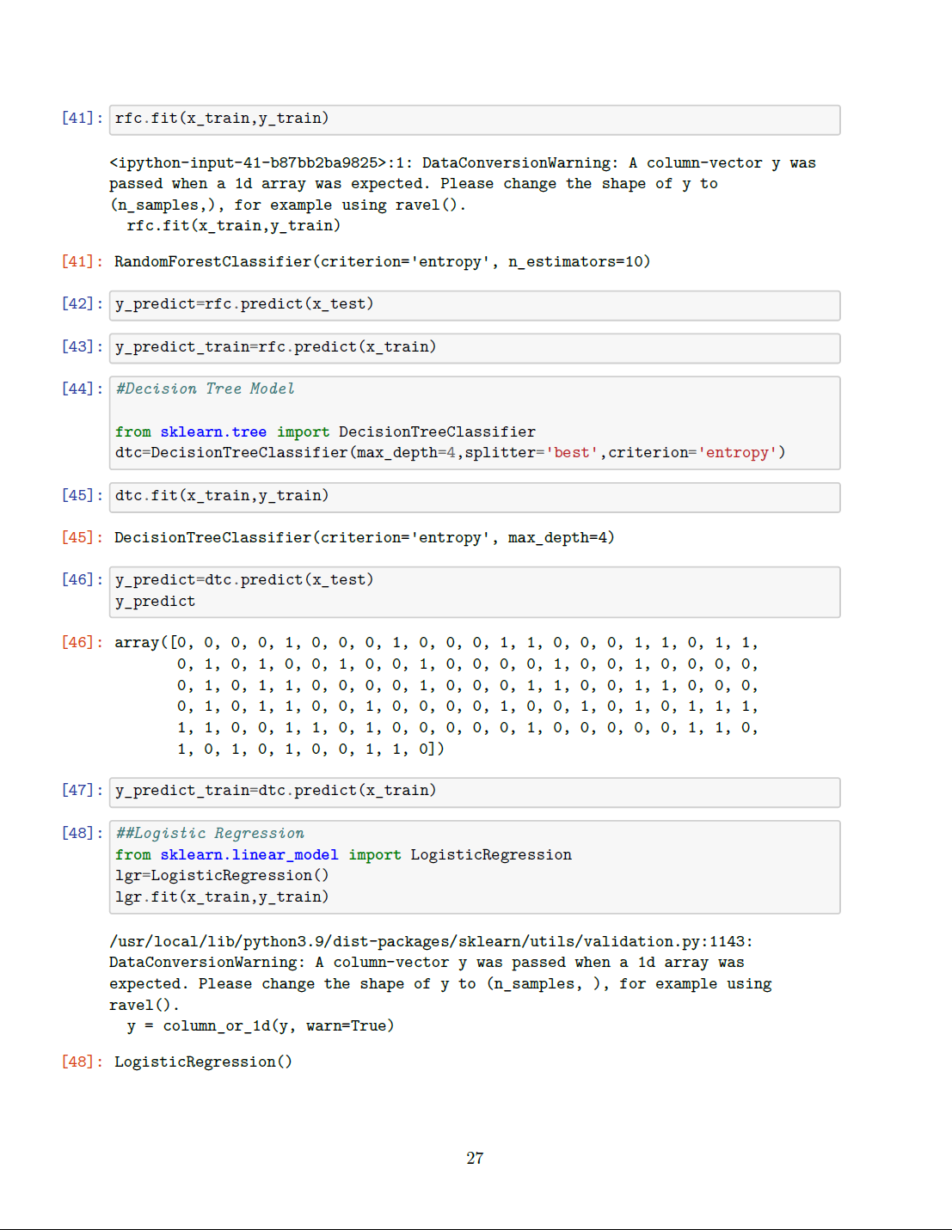

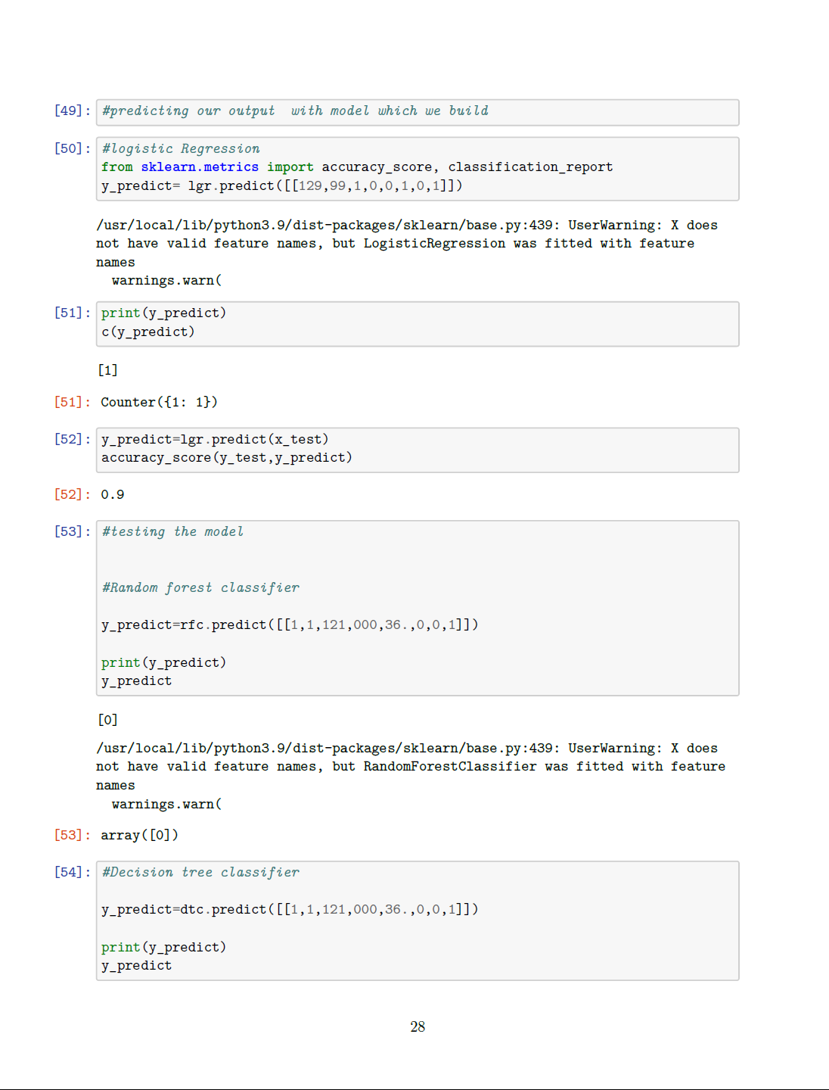

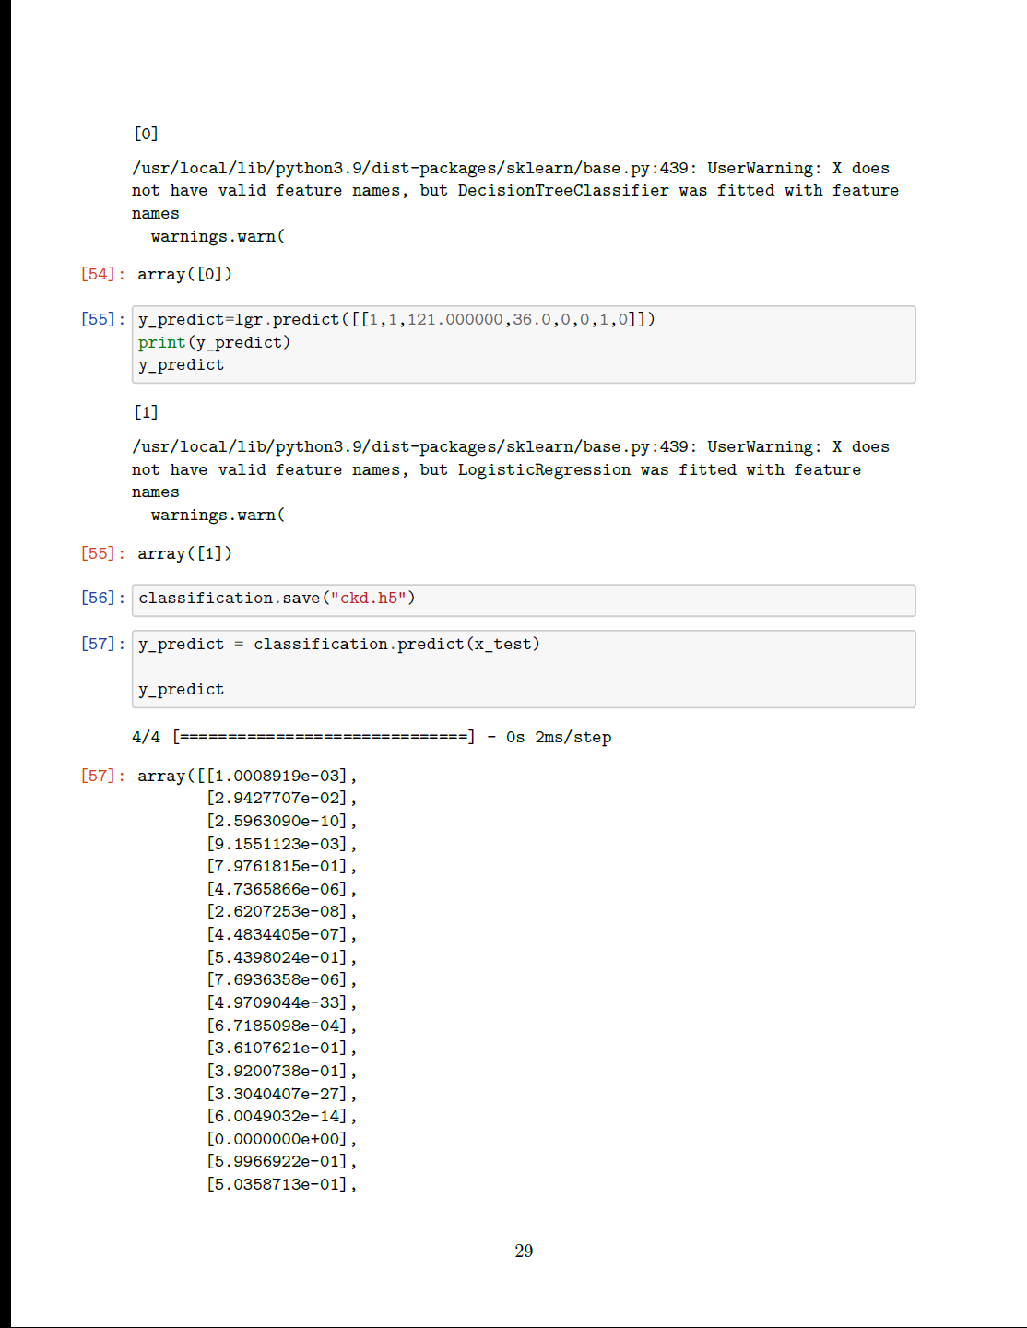

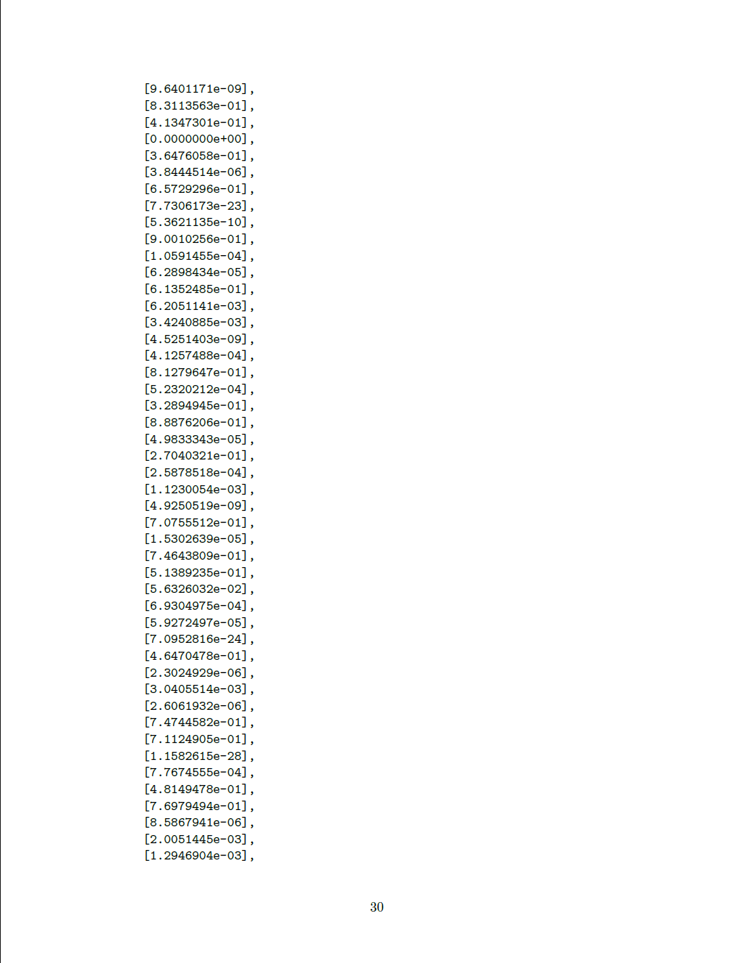

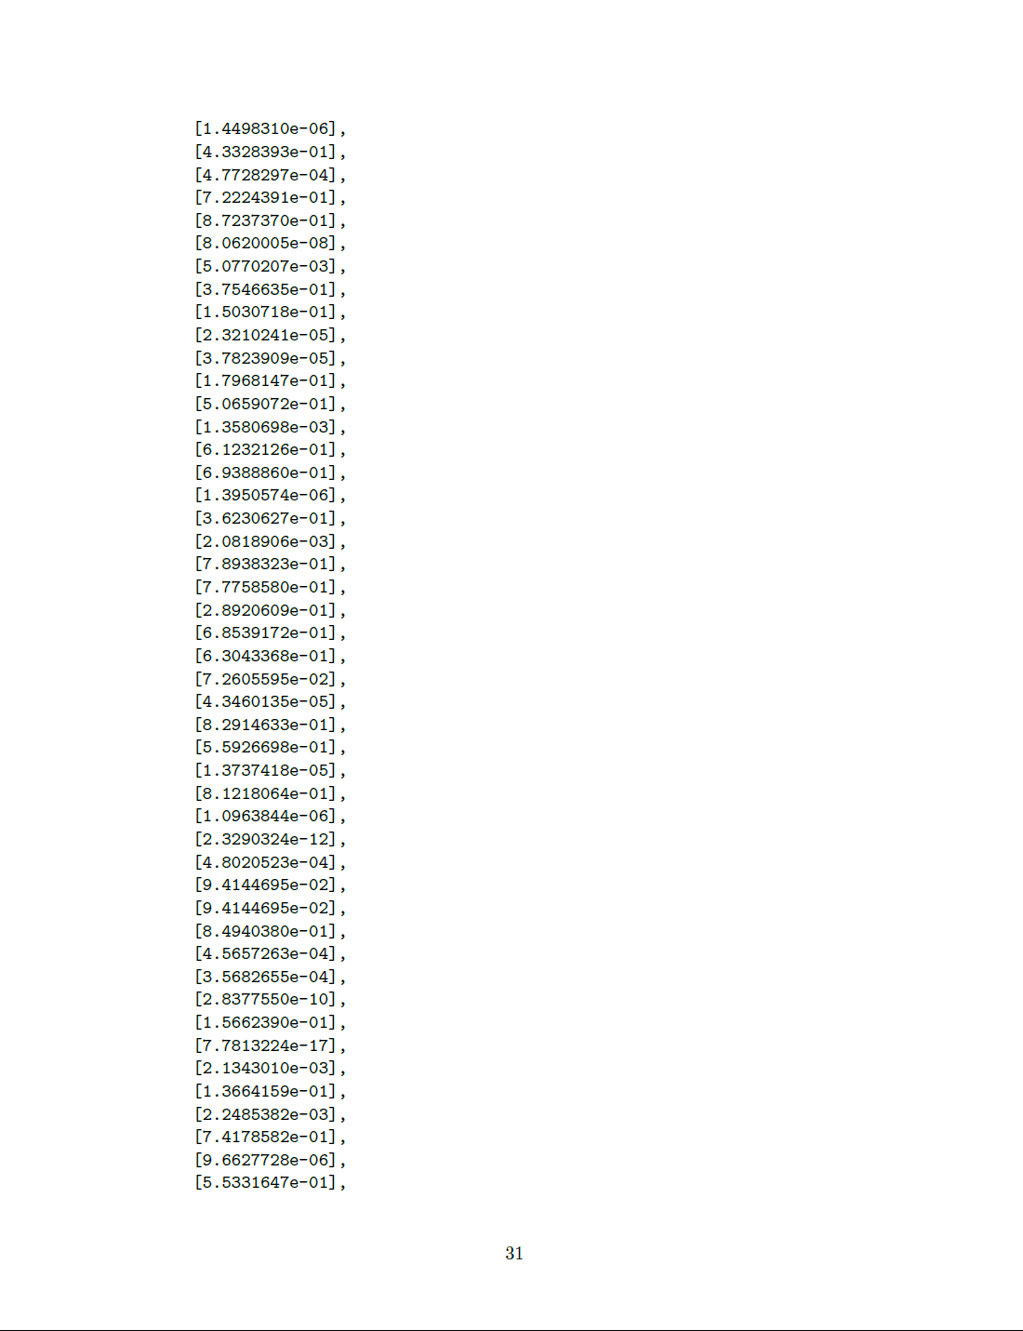

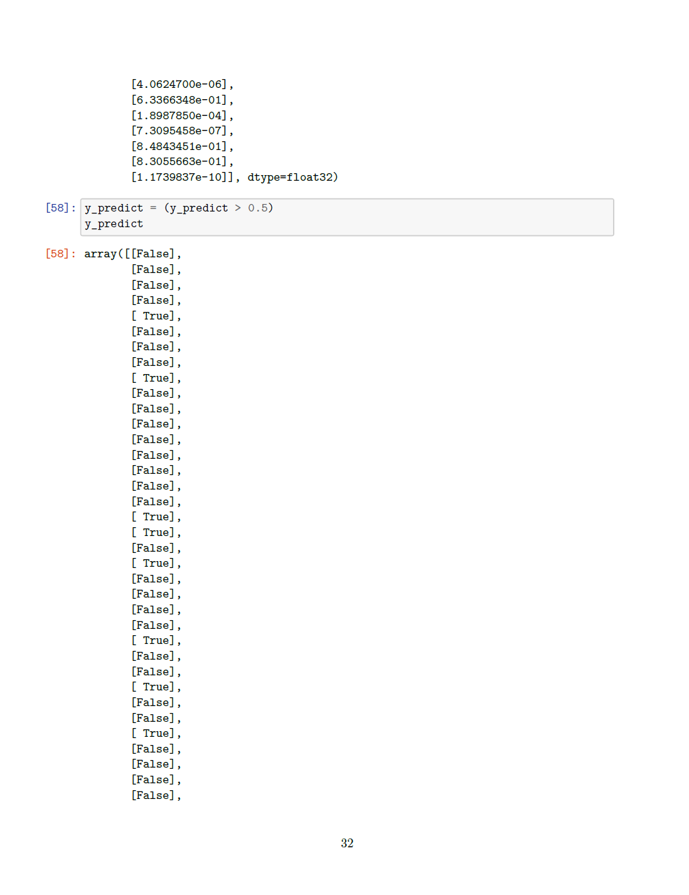

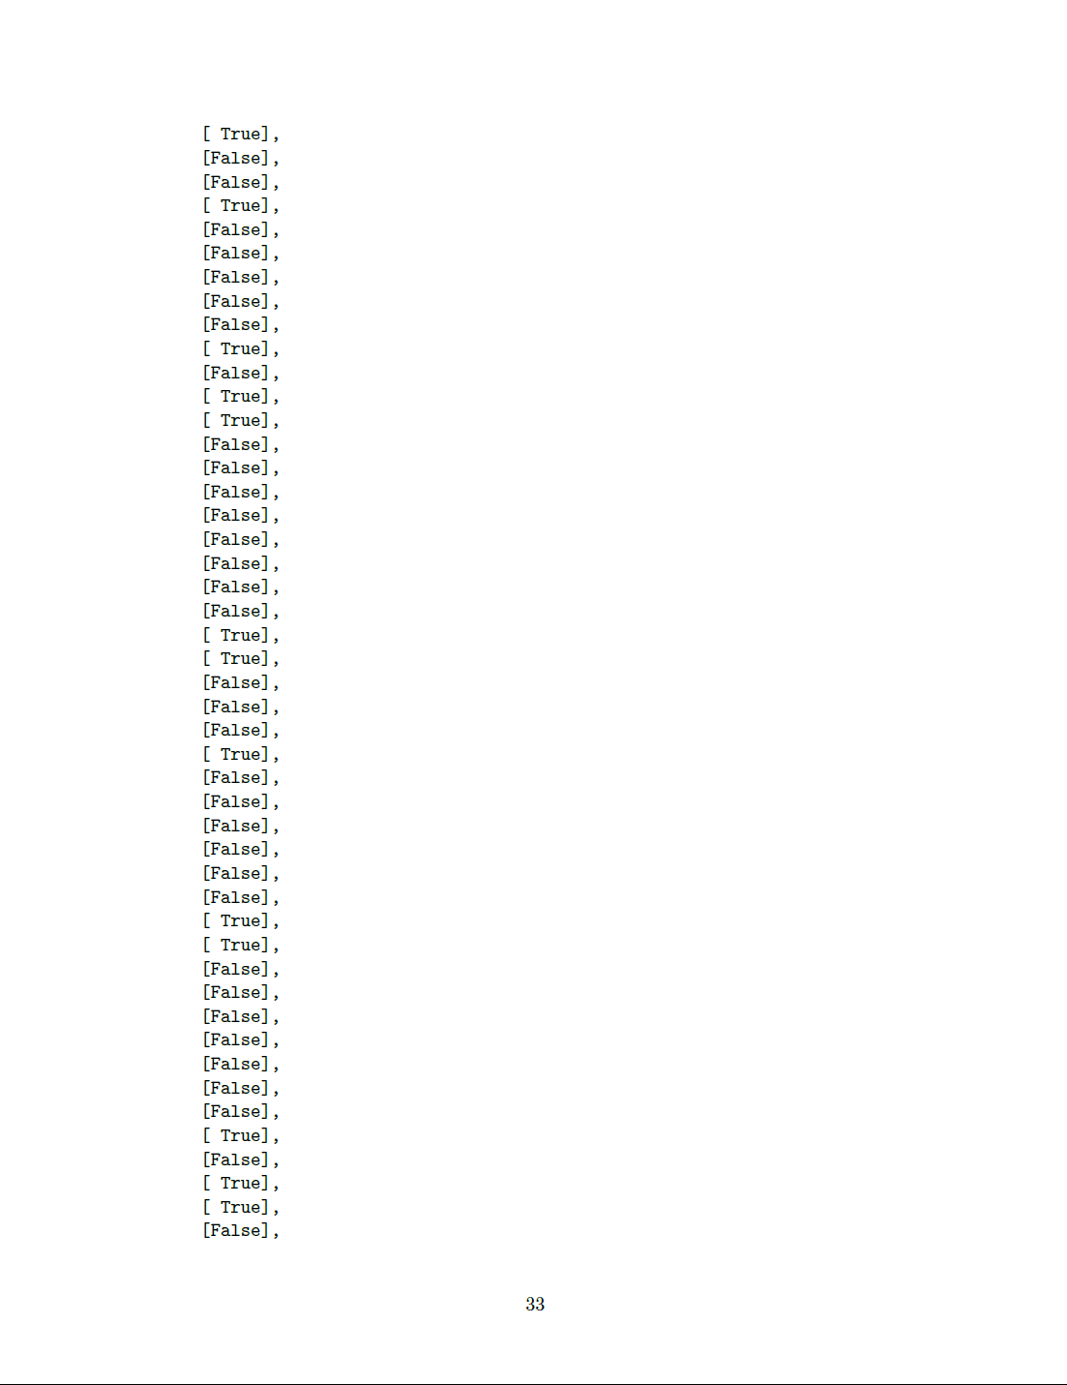

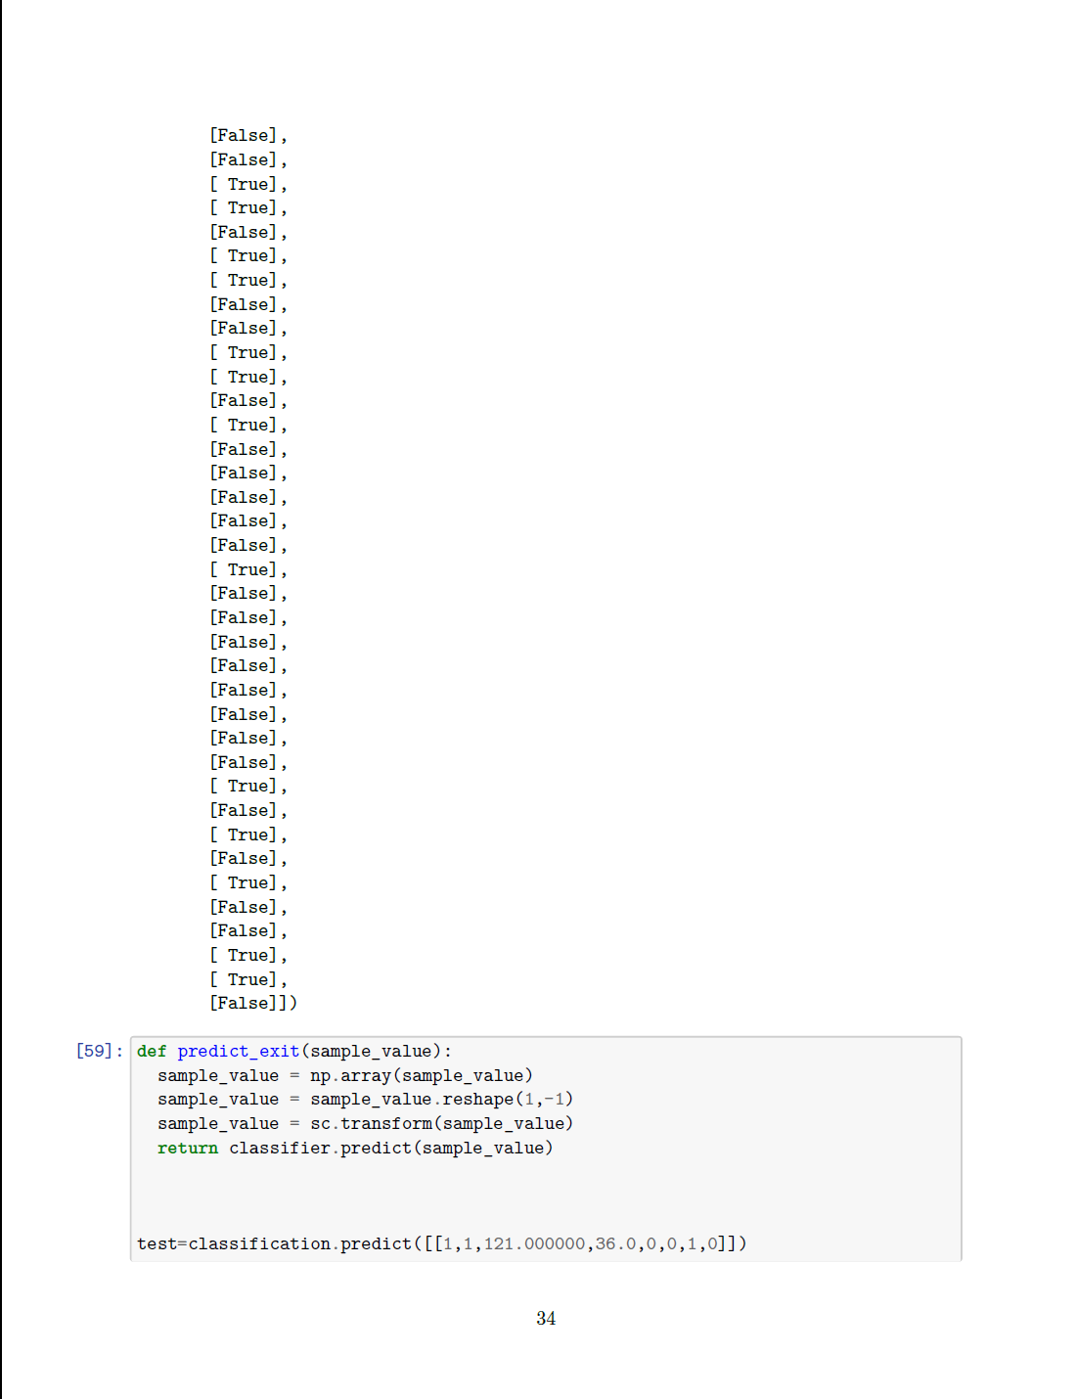

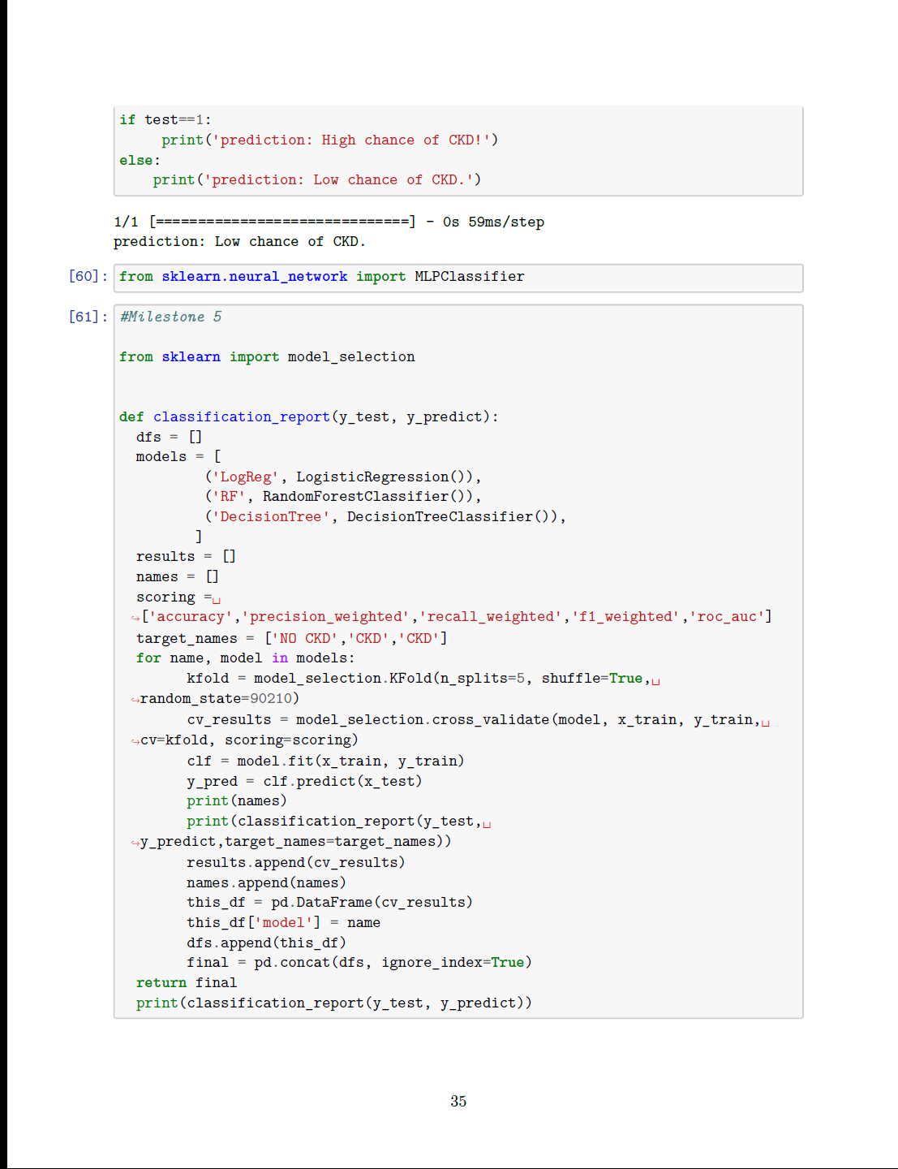

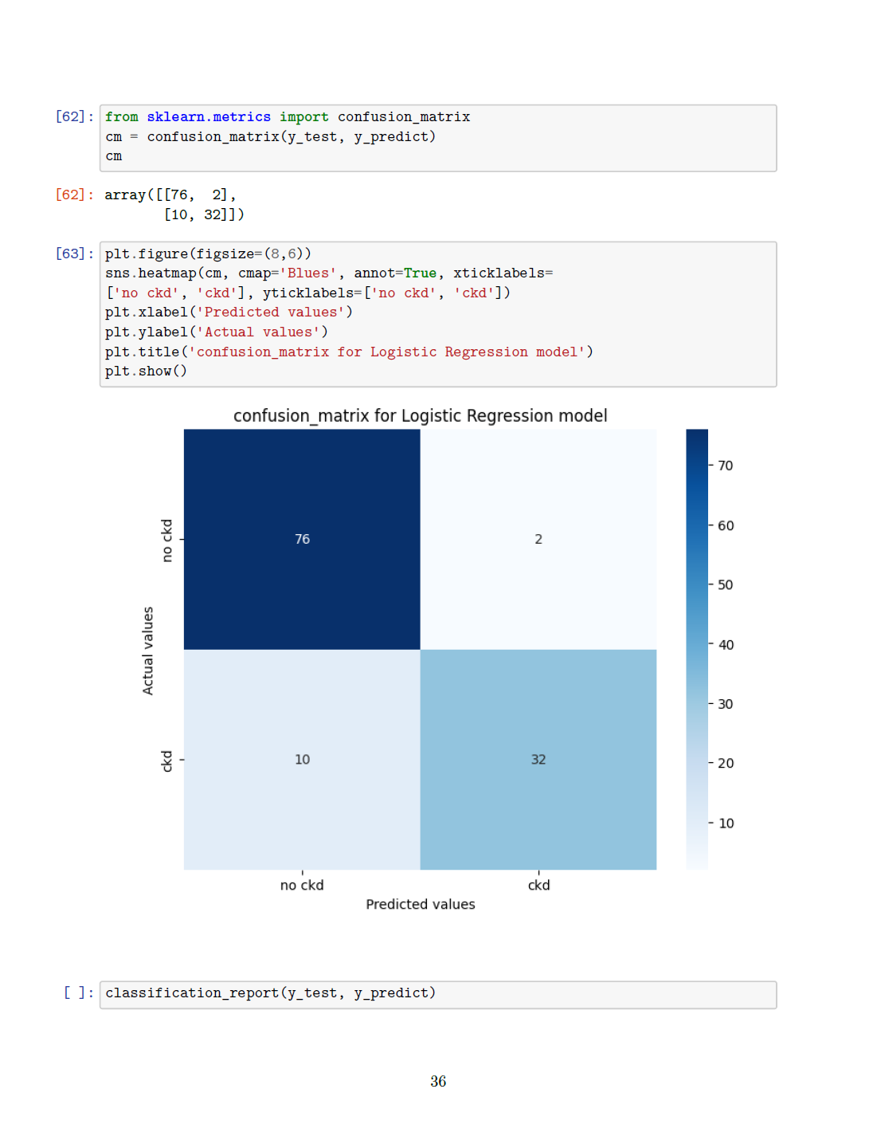

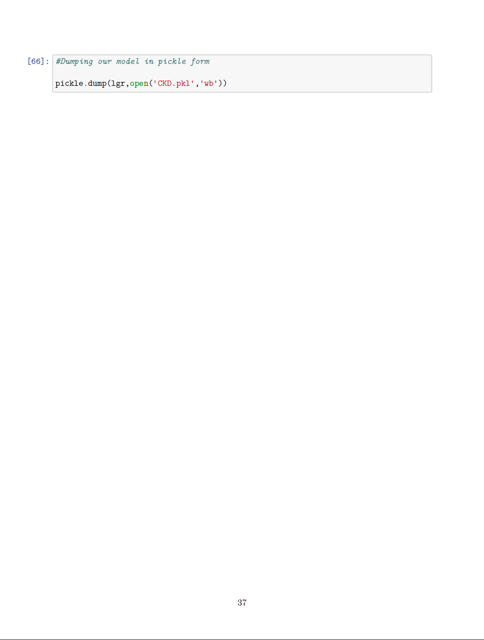

Milestone:6

#importing the necessary dependencies

importnumpyasnp

import pandas aspd

from flask importFlask,request,render_template

import pickle

importos

app=Flask(__name__,template_folder='templates') #iniatialize a Flask app

model= pickle.load(open(os.path.join('C:/Users/MOKESH/Desktop/Kidney Disease/Early Detection of Chronic kidney disease/Flask',

        'pkl_objects','CKD.pkl'),'rb'))

@app.route('/')#route to display home page

defhome():

    returnrender_template('home.html')

@app.route('/Prediction',methods=['POST','GET'])

defprediction():

    returnrender_template("index.html")

@app.route('/Home',methods=['POST','GET'])

defmy_home():

    returnrender_template('home.html')

@app.route('/Predict',methods=['POST']) #route to show prediction in web UI

defpred():

    #reading the inputs given by the user

    input_features=[float(x) for x inrequest.form.values()]

    features_value=[np.array(input_features)]

    features_name=['blood_urea','blood glucose random','anemia',

                    'coronary_artery_disease','pus_cell','red_blood_cells'

                    'diabetesmellitus','pedal_edema']

    df=pd.DataFrame(features_value,columns=features_name)

    #prediction using the loaded model file

    output=model.predict(df)

    #showing the prediction results in UI

    returnrender_template('result.html',prediction_text=output)

if__name__=='__main__' :

    #running the app

    app.run(debug=True)

Template

Home.html

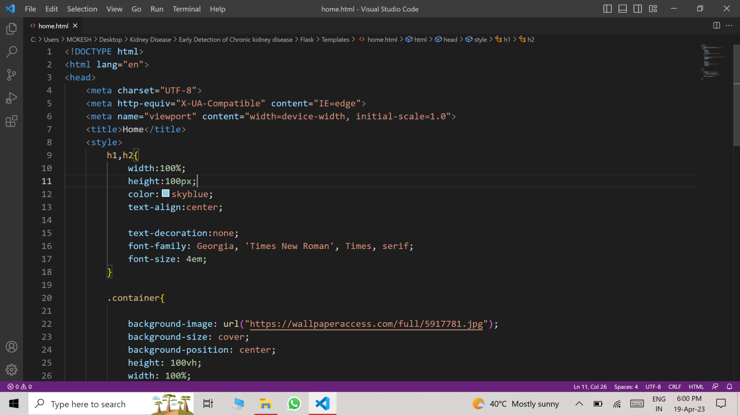

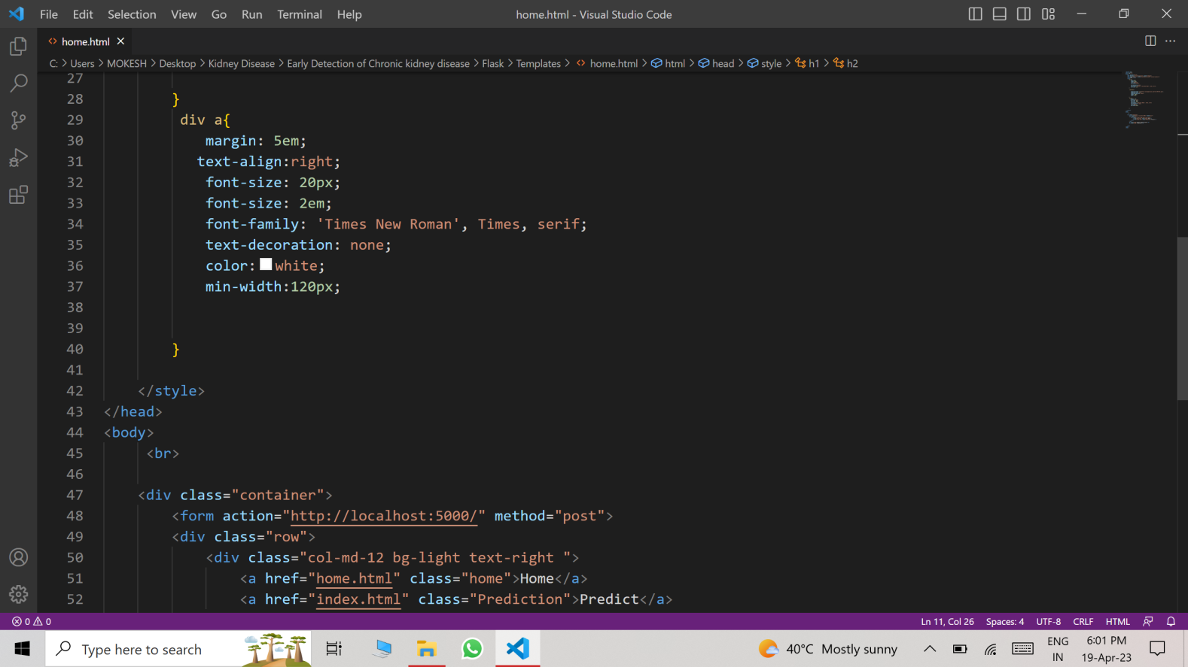

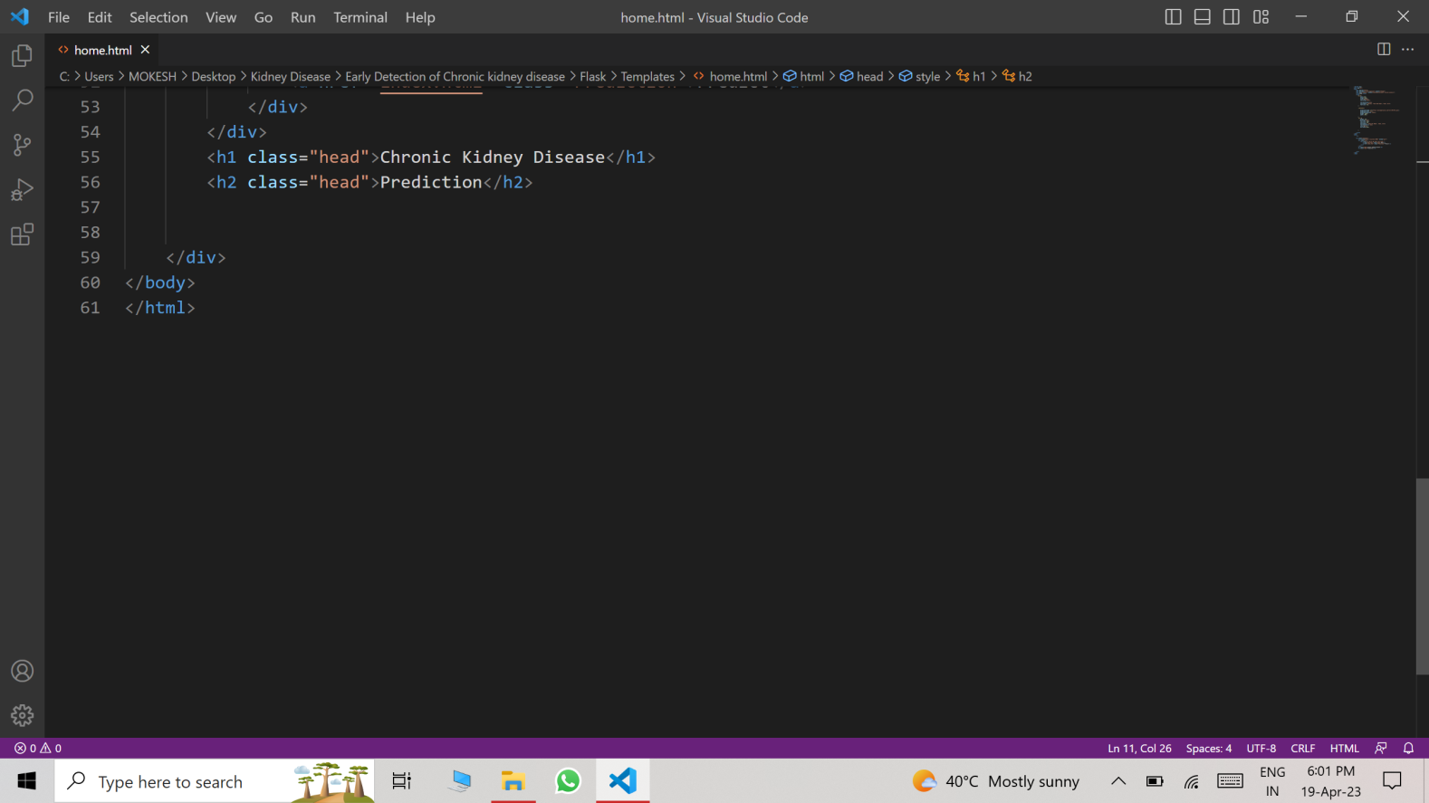

Index.html

